April 2020
Hello Tiddlers and Minnows,
I hope you all had a wonderful Easter break. We were so lucky to have such lovely weather, I hope you all got to enjoy the sunshine! I’m sure you all got to eat lots of yummy chocolate as well, how many Easter eggs did you get to eat?
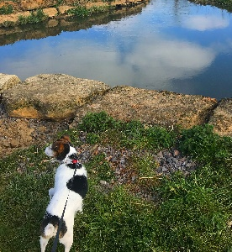
It was my birthday at the start of the Easter break and I got to spend the day outside soaking up the sunshine! I want to say a big thank you to all of you who wished me a happy birthday, I had the biggest smile on my face when I watched your videos on Tapestry. I have been trying to stay really busy over the Easter break by going on lots of walks with my dog and baking lots of delicious treats for me and my family. I have also been trying to keep my brain busy by learning to speak Welsh, I’m hoping I will get really good at it so I can surprise my Nan and Grandad who live in Wales. Hopefully, I will be able to teach you some Welsh when we are all back together. Have you been learning any new skills?
I’ve been thinking a lot about all the hard work you had been doing before school closure, you were all working so hard on your reading and writing, I was so proud of you all. Even though we only had a short amount of time together, the amount of progress you all made was amazing. I think you should all give yourselves a big marshmallow clap!
I miss you all a lot and can’t wait for us all to be together again. I have really enjoyed seeing all of the wonderful work you have been doing at home, I know lots of you have had great fun writing letters to your friends, baking cookies and doing lots of arts and crafts. Keep up the hard work and I can’t wait to see and hear about all the exciting things you get up to over the next couple of weeks.
Stay safe and I look forward to seeing you all when school is open again.

Miss Williams

