Friends of Fritwell School Newsletter

December 2019

Dear Parents and Carers,

As the Autumn term draws to a close and the Christmas Holiday’s lie in front of us, we wanted to send you an update from the FoFS team on progress for this school year.
We have had a great first term and thoroughly enjoyed each of the events we have brought to you. We hope you have enjoyed attending them as well.

Trail:-
The first event, the Autumn Trail, saw families heading out to try and solve the clues and win the first prize of book vouchers. This event raised £120.45 and brought out the competitive side in a few of us!

Fireworks:-
The second event was our annual Fireworks Display. It was another great show put on by Skyline and even the full moon came out to enjoy the evening. The event was a sell out and we were very pleased to raise £1508.68.

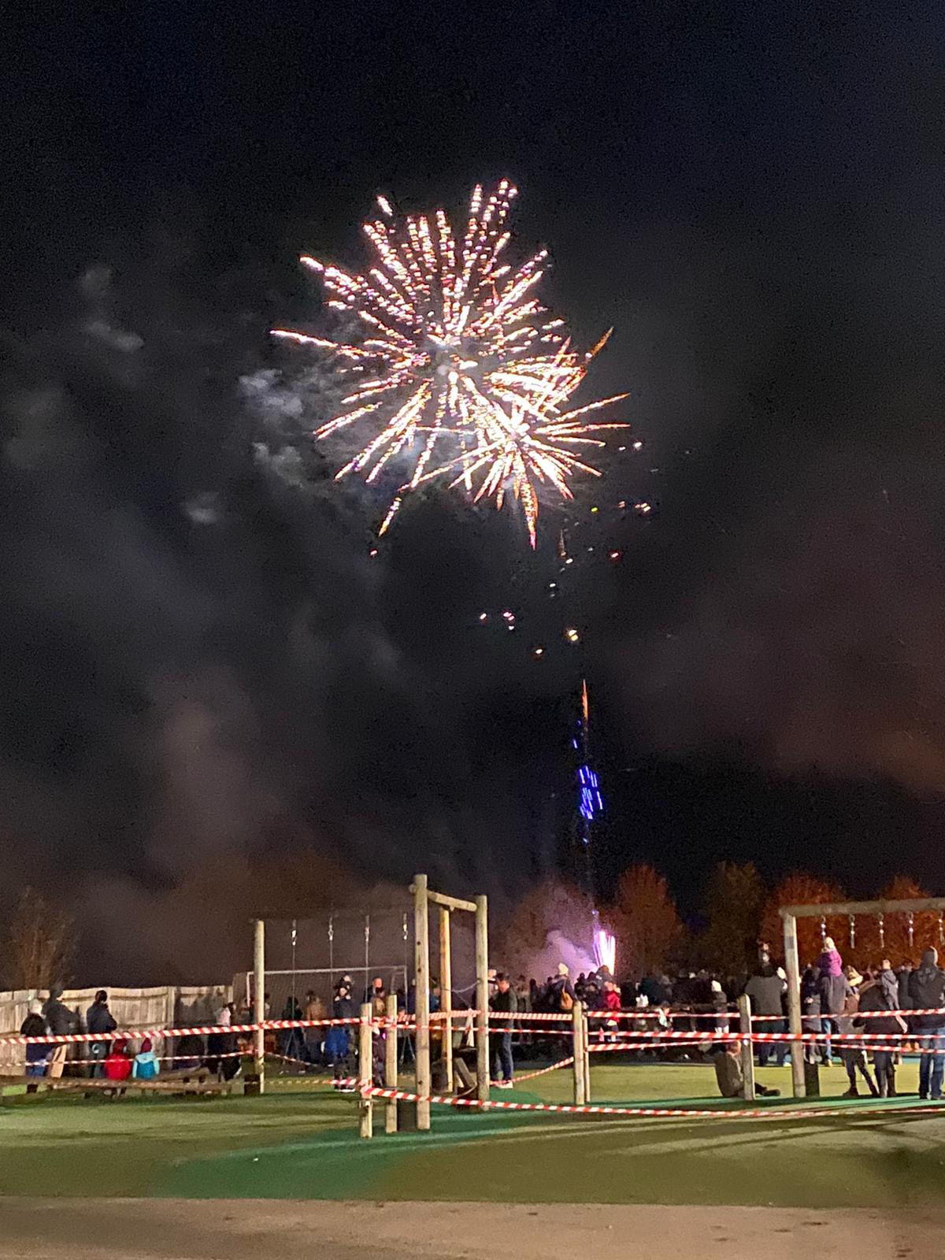

Christmas Craft Fayre:-
Our third event came quickly after. In its third year, the Christmas Craft Fayre was such a lovely, family friendly event. The bauble decorating was so busy and the end results were amazing! A special thank you to Jen Lyon for creating this wonderful addition to our fayre. All the stalls, especially our children’s, had excellent products and the stallholders said they enjoyed being part of the day. In total we raised an amazing £708.43.

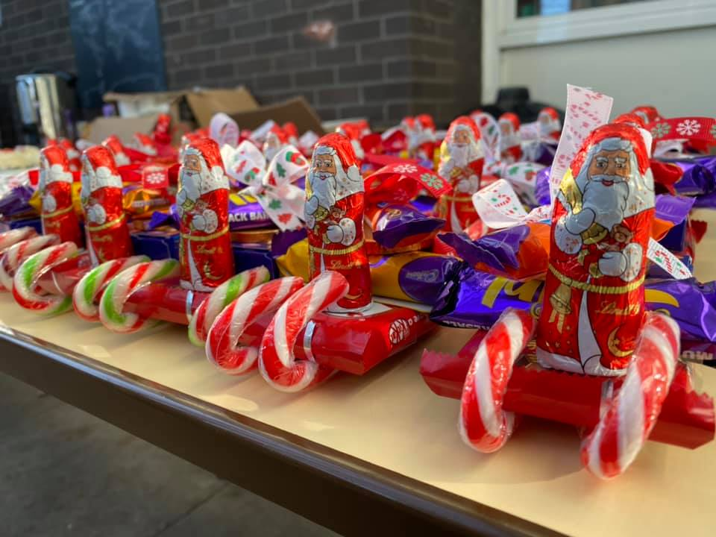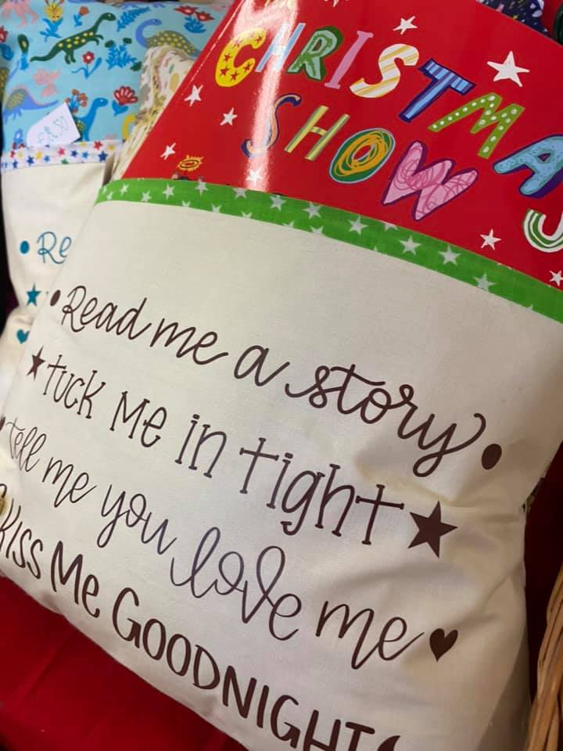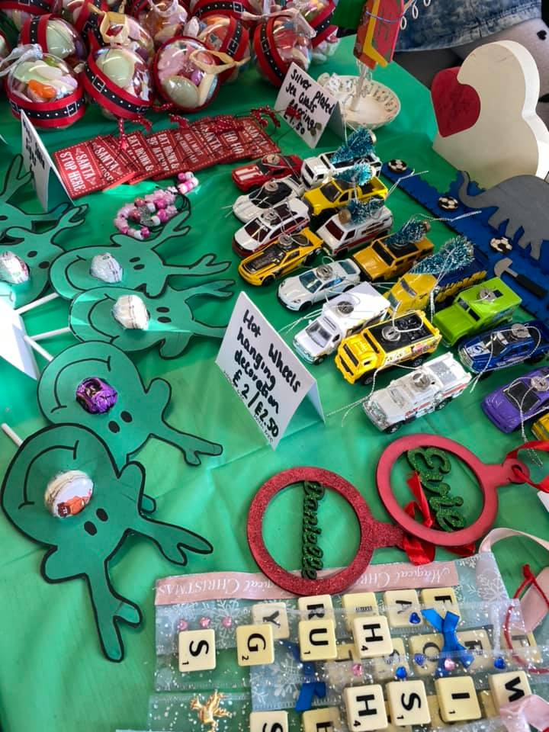

Secret Present Room:-
Our fourth event was one of the favourites in the calendar, Secret Present Room. This is such a special event and one that the volunteers and children enjoy immensely. This year saw a swing more to parent/carer presents, we think it was successful and we hope you all enjoy receiving your gifts on Christmas Day. This event raised £453.00.
All in all, FoFS have, with the help of teachers and parents, managed to raise an amazing £2,790.56. This is money that will go towards resources for the school.

Christmas Disco:-
In addition to these events we also had our Christmas school disco, run by two volunteer parents – Laura Gray and Lisa Green. The ladies changed the format a little, introducing hot food, and did a fabulous job. We are grateful for their efforts, thank you. All profits go to FoFS. The total raised was £435.05.

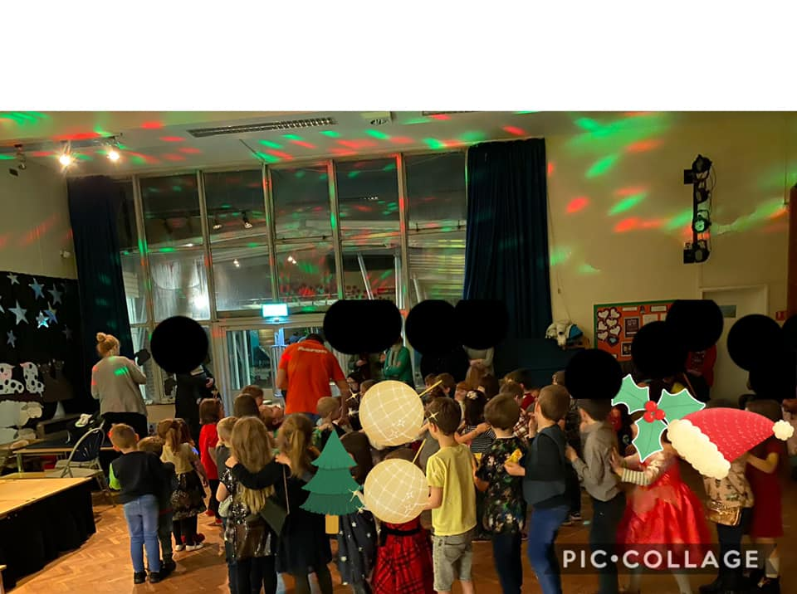

100 Club:-
The 100 Club will continue into 2020 and renewal forms have been sent out to all existing participants. Please may we ask you complete and return these with the relevant money ASAP. You can pay online if that is easier for you.
We still have numbers available for this. If you are interested in joining then please either contact Sophie Davies or Charlotte Robson. Alternatively let the school office know and we will get a form to you.

What Your Money Goes Towards:-
So far this school year, we have funded another interactive board for the school – the last one needed. Now all classes have one of these in their classroom.
We have also funded music lessons for years one and two for next term. We are looking forward to seeing how this is used.
In January there will be a pantomime being brought to the school for all the children to enjoy.

Upcoming Events:-
We have more events planned for the Spring and Summer terms. We hope you will continue to support us and enjoy them. Please see below some dates for your diaries.

28th February 2020 – Quiz

28th March 2020 – Easter Egg Hunt

4th July 2020 – Summer Event

We may introduce other events into the calendar, please keep an eye out for updates.

Thank you:-
Finally, we wanted to say a big thank you to everyone that helps to make FoFS a success. Teachers for helping, parents for volunteering and parents/carers for bringing their children to events and parting with their pennies. We really could not do this without any of you.

Wishing you all a very Merry Christmas and a Happy New Year

The FoFS Commitee

