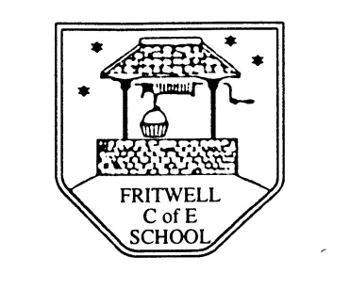
Breakfast Club Booking Form
Each session costs £5 and runs from 7.45-8.40am. Payment can be made by cheque (payable to Oxfordshire County Council) or cash. If you have more than one child please put them all on the same form and tick each day that you want to book.

Child’s Name: ………………………………………………………………………………………………………………. Date: ……………………………….
Spring Term 1 Wednesday 6th January to Friday 12th February 2021 Academic Year 2020-2021
DAY | Week  Beg  6th Jan | Week  Beg  11th Jan | Week  Beg  18th Jan | Week  Beg  25th Jan | Week  Beg  1st Feb | Week  Beg  8th Feb
Monday

Tuesday

Wednesday

Thursday

Friday

Payment via ParentPay

