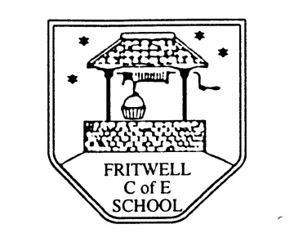
Breakfast Club Booking Form
Each session costs £5 and runs from 7.30-8.30am, your child can arrive at any point within that hour. If possible please enter your booking requirements per half term, so that we can plan staffing requirements. Payment can be made preferably by cheque (payable to Oxfordshire County Council), or if necessary with cash. If you have more than one child then please fill in one booking form per child. Tick each day that you want to book.
Child’s Name: …………………………………………………. Class: ……………………… Date: ……………………………….
Spring Term 1 Monday 7th January to Friday 15th February Academic Year 2018-2019
DAY | Week  Beg  7th Jan | Week  Beg  14th Jan | Week  Beg  21st Jan | Week  Beg  19th Nov | Week  Beg  28th Jan | Week  Beg  4th Feb | Week  Beg  11th Feb
Monday

Tuesday

Wednesday

Thursday

Friday

Total Payment enclosed £ ……………………….. cash/cheque (payable to Oxfordshire County Council)

