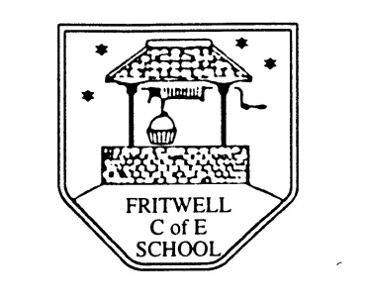
Breakfast Club Booking Form
Each session costs £5 and runs from 7.30-8.30am, your child can arrive at any point within that hour, but not before 7.30 please. If possible please enter your booking requirements per half term, so that we can plan staffing requirements. Payment can be made preferably by cheque (payable to Oxfordshire County Council), or if necessary with cash. If you have more than one child then please fill in one booking form per child. Tick each day that you want to book.
Child’s Name: …………………………………………………. Class: ……………………… Date: ……………………………….
Term 3 4 January-9 February Academic Year 2017-2018
DAY | Week  Beg  1 January | Week  Beg  8 January | Week  Beg  15 January | Week  Beg  22 January | Week  Beg  29 January | Week  Beg  5 February
Monday | Holiday
Tuesday | Holiday
Wednesday | Holiday
Thursday

Friday

Total Payment enclosed £ ……………………….. cash/cheque (payable to Oxfordshire County Council)

