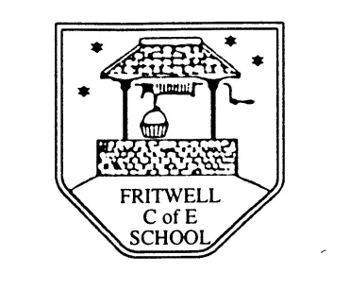
Breakfast Club Booking Form
Each session costs £5 and runs from 7.30-8.30am, your child can arrive at any point within that hour. If possible please enter your booking requirements per half term, so that we can plan staffing requirements. Payment can be made preferably by cheque (payable to Oxfordshire County Council), or if necessary with cash. If you have more than one child then please fill in one booking form per child. Tick each day that you want to book.
Child’s Name: …………………………………………………. Class: ……………………… Date: ……………………………….
Summer Term 1 Monday 23rd April to Friday 24th May Academic Year 2018-2019
DAY | Week  Beg  22nd April | Week  Beg  29th April | Week  Beg  6th May | Week  Beg  13th May | Week  Beg  20th May | HALF  TERM
Monday

Tuesday

Wednesday

Thursday

Friday

Total Payment enclosed £ ……………………….. cash/cheque (payable to Oxfordshire County Council)

