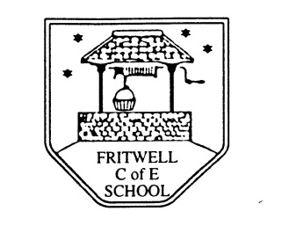

Fixed Term part-time Teaching Assistant until December 31st 2019
For the TA role Grade 4 Point 4 £18,426 pro rata

Would you like to be part of a caring and supportive school, where the children have outstanding attitudes to learning and the staff have high expectations to ensure all children reach their full potential? The role will be based in our year 2/3 class for 15 hours per week, working mornings during term time only.
We can offer you:
- A nurturing learning environment where all are respected and valued
- Caring, well behaved and respectful children with positive attitudes to learning
- An opportunity to work as part of an effective and supportive team
- A commitment to staff training and development
- Attractive, spacious and well-resourced accommodation

We are looking for someone who:
- Is committed to ensuring an excellent standard of education for all our children
- Will be committed to the Christian ethos of our school
- Enjoys working in collaboration with other staff, teachers and the wider partnership of schools
- Has a GCSE Grade C in English and Maths

Contract information:

Start date: as soon as possible
Probationary period: 3 months
Contract type: fixed term to December 31st 2019
Notice period: 1 month from either party

We welcome and actively encourage a visit to our school, so if you would like to come and meet us and see the school in action then please contact Val Latham in the school office on 01869 345283 or email office.3065@fritwell.oxon.sch.uk
To apply, please fill in the Oxfordshire Support Staff Application Form which you will find on our school website together with additional information about the job, or alternatively email Val on the office email for a job pack.
Applications must be emailed to the office on the email address above.
Deadline for applications: 15th May 2019 15.00pm Interview date: 17th May 2019

