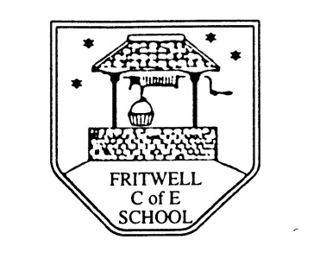
Breakfast Club Booking Form
Each session costs £5 and runs from 7.45-8.40am. Payment can be made by cheque (payable to Oxfordshire County Council) or cash. If you have more than one child please put them all on the same form and tick each day that you want to book.

Child’s Name: ………………………………………………………………………………………………………………. Date: ……………………………….
Autumn Term 1 Thursday 3rd September to Friday 23rd October 2020 Academic Year 2020-2021
DAY | Week  Beg  31st Aug | Week  Beg  7th Sept | Week  Beg  14th Sept | Week  Beg  21st Sept | Week  Beg  28th Sept | Week  Beg  5th Oct | Week  Beg  12th Oct | Week  Beg  19th Oct
Monday

Tuesday

Wednesday

Thursday

Friday

Total Payment enclosed £ ……………………….. cash/cheque (payable to Oxfordshire County Council)

