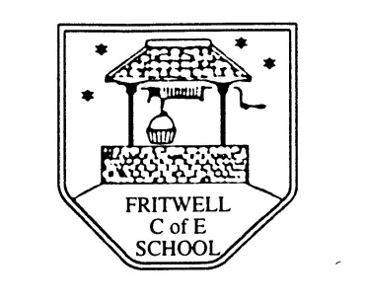
Breakfast Club Booking Form
Each session costs £5 and runs from 7.45-8.40am. Payment can be made by cheque (payable to Oxfordshire County Council) or cash. If you have more than one child please put them all on the same form and tick each day that you want to book.

Child’s Name: ………………………………………………………………………………………………………………. Date: ……………………………….
Autumn Term 1 Thursday 2nd September to Friday 22nd October Academic Year 2021-2022
DAY | Week  Beg  30th Aug | Week  Beg  6th Sept | Week  Beg  13th Sept | Week  Beg  20th Sept | Week  Beg  27th Sept | Week  Beg  4th Oct | Week  Beg  11th Oct | Week  Beg  18th Oct
Monday

Tuesday

Wednesday

Thursday

Friday

Payment via ParentPay

