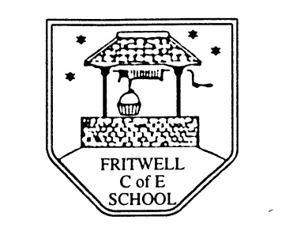
Breakfast Club Booking Form
Each session costs £5 and runs from 7.40-8.40am, your child can arrive at any point within that hour. If possible please enter your booking requirements for a full term, so that we can plan staffing requirements. Payment can be made preferably by cheque (payable to Oxfordshire County Council), or if necessary with cash. If you have more than one child then please fill in one booking form per child. Tick each day that you want to book.
Child’s Name: …………………………………………………. Class : ……………………… Date: ………………………………….
Term 1 Academic Year 2015-2016
DAY | Week Beg  31st Aug | Week  Beg  7th Sept | Week Beg  14th Sept | Week  Beg  21st Sept | Week  Beg  28th Sept | Week  Beg  5th Oct | Week  Beg  12th Oct | Week  Beg  19th Oct
Monday | Holiday
Tuesday | INSET
Wednesday | INSET
Thursday

Friday |  |  |  |  |  |  | INSET

Total Payment enclosed £ cash/cheque (payable to Oxfordshire County Council)

