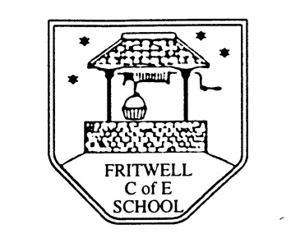
Breakfast Club Booking Form
Each session costs £5 and runs from 7.30-8.30am, your child can arrive at any point within that hour. If possible please enter your booking requirements per half term, so that we can plan staffing requirements. Payment can be made preferably by cheque (payable to Oxfordshire County Council), or if necessary with cash. If you have more than one child then please fill in one booking form per child. Tick each day that you want to book.
Child’s Name: …………………………………………………. Class: ……………………… Date: ……………………………….
Spring Term 2 Monday 25th February to Friday 5th March Academic Year 2018-2019
DAY | Week  Beg  25th Feb | Week  Beg  4th Mar | Week  Beg  11th Mar | Week  Beg  18th Mar | Week  Beg  25th Mar | Week  Beg  1st Apr | EASTER  HOLIDAYS
Monday

Tuesday

Wednesday

Thursday

Friday

Total Payment enclosed £ ……………………….. cash/cheque (payable to Oxfordshire County Council)

