Sharks Spring Term Newsletter
Growing and learning together with God

Dear Parents and Carers, January 2022
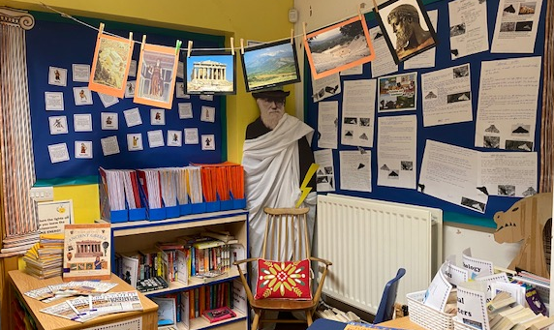
We hope you all had a lovely break over the Christmas holidays and are enjoying a productive start to the New Year!

As the country begins to relax social distancing measures, we are continuing to ensure that classrooms are well ventilated and are encouraging good hygiene with regular hand washing. To support with this, children are welcome to bring anti-bac hand gel into school and we also recommend ensuring they have a jumper with them every day as we continue to keep windows open to ensure good ventilation.

Communications
Parents evenings will be taking place on the 8th, 15th and 16th of March, when we can discuss progress in children’s learning. However if you have individual concerns about your child or any other queries, please do not hesitate to either speak to class adults on the playground at the end of the day or contact the school office.

Keep an eye on the weekly school newsletters to find out what we have been learning about each week; we will also be updating the Sharks Class page on the website a couple of times each term with news and photos of our learning journey.

Topic
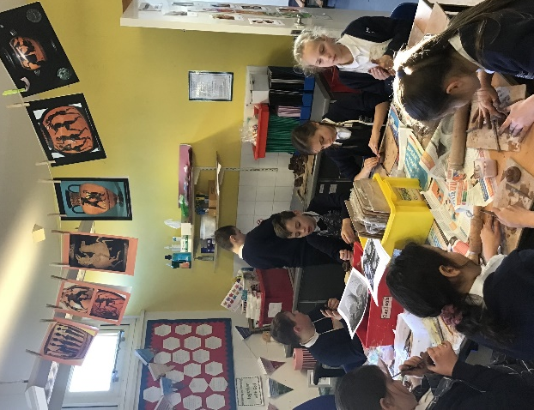
This term we have travelled back in time to Ancient Greece, an exciting topic to inspire our learning! In English lessons we are reading Greek myths and legends, using these to inspire our own writing – describing mythical creatures, plotting our own myths and trying to persuade Greek characters to agree with our point of view. In History lessons we are finding out about life in Ancient Greece, and exploring the Greek legacy to modern day life; this has included working with clay to make Greek pots and masks in Art lessons and we will continue to explore Greek cooking in DT.
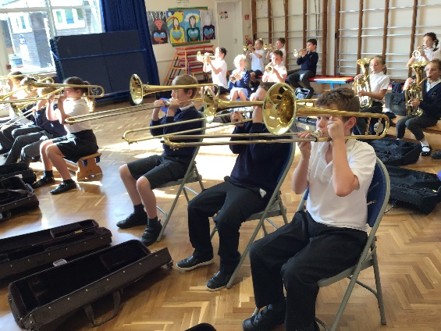
In RE we are learning about the Sikh religion and how people show commitment to their beliefs; in the lead-up to Easter we will also be considering the question What did Jesus do to save human beings? Our SCARF PHSE will focus on Being my Best and Valuing Differences; we are also learning about Zones of Regulation as an approach towards managing emotions and behaviour. Our Science work involves investigating the properties of materials and considering the effect this has on their uses. Year 6 continue to receive brass lessons from Mr Probert on Tuesday mornings, while Year 5 will be taught Music by Sharks teaching staff.
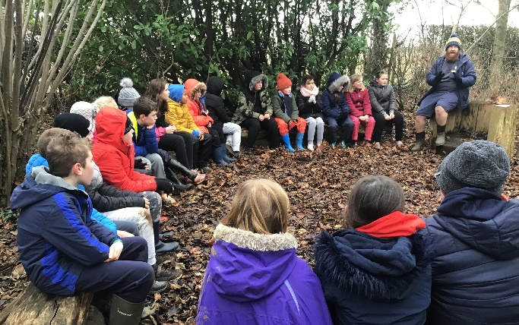
PE
During the first half of term, Sharks are lucky to have Forest School on Friday afternoons. It is important they remember appropriate kit to keep them warm and dry because we spend the afternoon outside whatever the weather; this should also be clothing they do not mind getting muddy!

We also have PE on Wednesday afternoons, where we will be developing Hockey skills ahead of a partnership tournament in February. We will then be learning Dance, inspired by the theme of the Greek gods. Please ensure that children have navy blue shorts, t-shirt, trainers and appropriate warm clothing for going outside, and that all items are clearly named. PE kits should be in school every day in case PE sessions change; they will be sent home on a Friday so that the cloakrooms can be thoroughly cleaned.

After half term, those children in Year 6 who have not yet achieved the national curriculum requirement of swimming 25m will be invited to additional swimming lessons on Friday afternoons in order to support them in achieving this expected level of water safety.

Water bottles and snacks
Children should remember to bring a bottle of water (not squash) into school to keep in the classroom every day; water bottles can be re-filled during the day. If children are bringing in snack for break time, please remember this should be healthy food like a piece of fruit.

Home Learning
Project homework will continue to be set whereby children choose which projects to complete from a variety of themes; these will be shared with the class and feedback given. Details about our Ancient Greece project options will be sent out as an assignment on Teams, where supporting resources are also available.

All children have Spelling Shed and Times Table Rock Stars log-ins which they should be using regularly to keep practising key skills.
- On Mondays we will check that children have been using TTRockstars to practise their times tables for a total of 20 minutes across the week
- On Tuesdays we will check that children have accessed Spelling Shed a minimum of three times a week. Spelling practise sheets are available as an alternative if children do not have internet access at home.
- On Fridays we will check that children have been reading at home and recording this in their Reading Record a minimum of three times a week.

SATS Booster Groups
After February half term, we are arranging booster groups to help Year 6 prepare for their SATS, which will be happening in the week beginning 9th May. Year 6 children may receive additional homework to help them prepare for these sessions. More information about SATS and boosters will follow in due course.

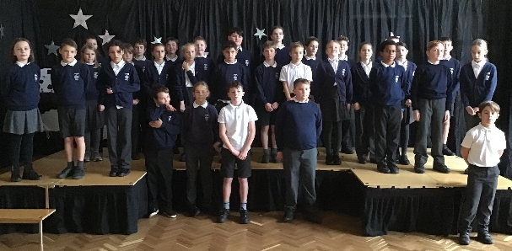
Sharing Assembly
We are looking forward to another great term of learning and growing together, and are pleased to invite parents into school for a special sharing assembly at 2:45 on Tuesday 8th March, where we will share with you some of our learning from this term.
We look forward to seeing you then!
Mrs Montgomery – Class Teacher
Mrs Weaver and Mrs England – Sharks TAs
Mr Hart – teaching on Thursday afternoons
Mr Parsons – Oxford Brookes PGCE student

