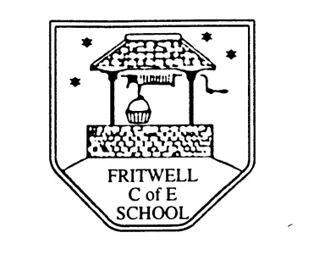
Breakfast Club Booking Form
Each session costs £5 and runs from 7.30-8.30am, your child can arrive at any point within that hour. If possible please enter your booking requirements per half term, so that we can plan staffing requirements. Payment can be made preferably by cheque (payable to Oxfordshire County Council), or if necessary with cash. If you have more than one child then please fill in one booking form per child. Tick each day that you want to book.
Child’s Name: …………………………………………………. Class: ……………………… Date: ……………………………….
Term 1 4 Sept-20 October Academic Year 2017-2018
DAY | Week  Beg  4 Sept | Week  Beg  11 Sept | Week  Beg  18 sept | Week  Beg  25 Sept | Week  Beg  2 Oct | Week  Beg  9 Oct | Week  Beg  16 oct
Monday | INSET
Tuesday | INSET
Wednesday

Thursday

Friday |  |  |  |  |  |  | INSET

Total Payment enclosed £ ……………………….. cash/cheque (payable to Oxfordshire County Council)

