Sharks Topic Projects Spring 1
Here are our home learning project tasks linked to our topic this term. Choose three activities and return your projects either in person or via Teams by Friday 25th March and we will share our work in class during the last two weeks of term.

As always, I’d like to encourage you to interpret each project in a way that inspires you; it is up to you how you present your work – a piece of writing, a photo of something you have made, video, a PowerPoint – be as creative as you like!
Greek Gods  Do you have a favourite Greek God? Find out about one of the Greek Gods – what were they the god of? Who worshipped them and how? Did they have a special symbol? Are there any famous stories about them?  You might like to present your work in a poster or power point. You may choose to dress up as your Greek God and record a video in role. Or you could re-tell a myth about your favourite god. | Greedy Greeks  We enjoyed making Horiatiki (Greek salad) in school, which contains the special Greek ingredients like feta cheese and olives. There are many other delicious Greek ingredients and meals that you may like to find out about and if possible make.  While it would be great if you had the chance to taste some Greek foods and try cooking, this does NOT have to be a practical task. You could create a presentation about Greek foods or write your own recipe suitable for an Ancient Greek cook.
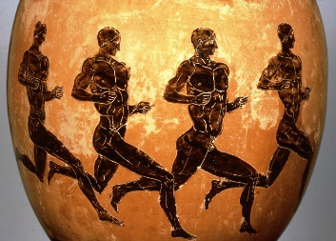  Ancient Athletes  A lasting legacy from Ancient Greek times are the Olympic games!  You could do some research into the Olympics. What were the original Olympics like? How do the Ancient Greek Olympics compare to the Olympic Games today?  Or you could think about the skills needed to compete in an Olympic event. Are any of the sports that you take part in Olympic sports? You could design a training schedule to develop the necessary strength, speed and skills of an Olympic athlete. Are you able to follow this schedule yourself? | Gorgeous Greece  Nowadays, Greece is a popular holiday destination, not only for those who want to visit temples and ancient sites, but also for beach holidays.  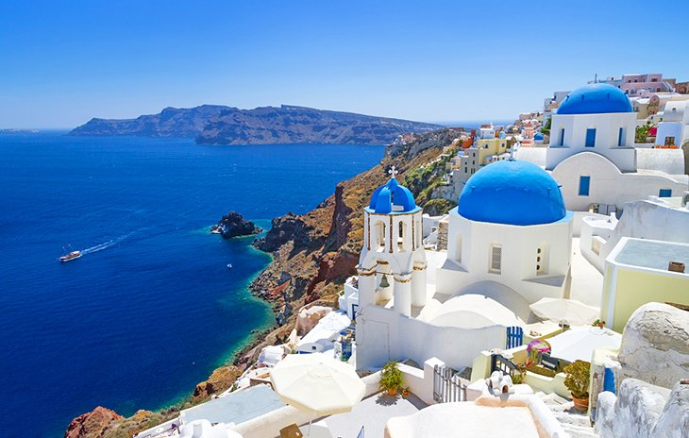  Can you find out where Greece is, what the weather is like, what the landscape is like? What sites are there to visit or activities to do on holiday?  You could write an information text on the geography of Greece or you could imagine you are a travel agent and create a brochure advertising a holiday to Greece.
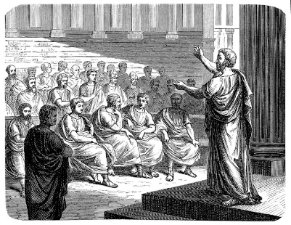  Greek Government  The Ancient Greeks invented the democratic approach to government used in our country today, where citizens have a say in the way the country is run by voting to elect leaders.  You could research Ancient Greek government – who could vote, how, and what kinds of things they voted for.  Or you might want to take a more current approach and find out about different types of government used in different countries around the world. Or you may wish to find out about the people and parties involved in government in the UK today.  You may have strong feelings about what you would change in our school or country and could choose to write your own speech explaining why you believe you should be elected to government and what your policies would be if elected. | Mesmerising Myths  In school we have started reading some ancient Greek myths, especially the Labours of Heracles.  You may choose to continue your exploration of Greek myths: there are lots of great versions of Greek Myths, from traditional re-tellings to modern adaptations like Percy Jackson.  You could write a book review to recommend your favourite myth to the rest of the class. You might choose to create a piece of drama or a comic strip re-telling your favourite myth.  In Ancient times, many myths would have been told orally rather than written down in books. Could you learn a Greek myth to tell from memory?  Or would you like to write your own Greek myth? Perhaps your own re-telling of a familiar myth or making up your own story using Ancient Greek themes and characters.
Know the Numerals  Much like Roman numerals, Greek numerals used letters of the Greek alphabet to represent different numbers.  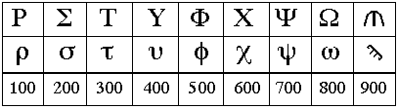  Can you research the Greek number system? How would you explain it to someone? Could you create an information poster or a game (like the matching pairs game we played to learn the roman numerals)? Can you create some number sentences using Greek numerals? | 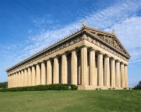  Ancient Architecture  Ancient Greek architecture is famous for its temples and columns, including the Doric, Ionic and Corinthian styles. We have also read about a mythical inventor, Daedalus, who build the legendary labyrinth for King Minos of Crete.  Why not take inspiration from ancient architects! You could research famous Greek buildings or styles of design. Or design or build your own temple, labyrinth, topless towers of Ilium, or a Trojan horse!

