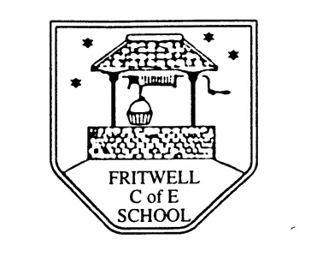
Breakfast Club Booking Form
Each session costs £5 and runs from 7.30-8.30am, your child can arrive at any point within that hour. If possible please enter your booking requirements per half term, so that we can plan staffing requirements. Payment can be made preferably by cheque (payable to Oxfordshire County Council), or if necessary with cash. If you have more than one child then please fill in one booking form per child. Tick each day that you want to book.
Child’s Name: …………………………………………………. Class: ……………………… Date: ……………………………….
Term 6 5th June-21st July Academic Year 2016-2017
DAY | Week  Beg  5 June | Week  Beg  12 June | Week  Beg  19 June | Week  Beg  26 June | Week  Beg  3 July | Week  Beg  10 July | Week  Beg  17
Monday | INSET
Tuesday

Wednesday

Thursday

Friday

Total Payment enclosed £ ……………………….. cash/cheque (payable to Oxfordshire County Council)

