Dear Sticklebacks class,
I hope you and your families are all well and have had a lovely Easter. Have you enjoyed eating all your Easter eggs? Hopefully, they haven’t melted in all this beautiful sunshine we’ve been having!
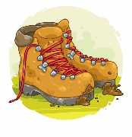
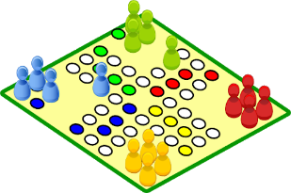
Over the Easter holidays, I have enjoyed playing lots of board games with my children. Unfortunately, I haven’t won many times – Naomi and Nathan are much better than me at Downfall, Snakes and Ladders and Trivial Pursuit; I obviously need to practise more. We have also been on lots of walks and bike rides around our village and have explored new footpaths and bridal ways. We have even seen some of you out and about and stopped for a quick chat (adhering to social distancing rules, of course). I have had to learn how to use video chats such as Zoom and WhatsApp so I can stay in touch with my family and friends in other parts of the country and abroad.
I would love to hear how you’ve been getting on with your home learning activities. I have seen some of your photos on Facebook and there are some fabulous, creative ideas of how you are filling your time each day. I would love to hear from you and to see some more pictures of what you’ve been doing. Your parents and carers will have been told that there is a new email address at school where you can send the teachers any messages, photos or any work that you’ve been doing. Send me a message; it would be lovely to hear from you and to know that you are all safe and well.
I spent the first couple of weeks before Easter thinking about how much progress you’ve all made this year and looking at the areas in which you have improved. You should all be so proud of the work you have put in during your time in Sticklebacks. You have made great progress in reading, writing and maths and it was a pleasure to complete all your assessments and send all the information to Mr Hart.
I miss you all lots and I am missing all of the teachers as well. I am looking forward to the time when we can all be back at school and work again.
Stay safe, look after each other and I look forward to seeing you all soon.
Mrs Ejiogu xx

