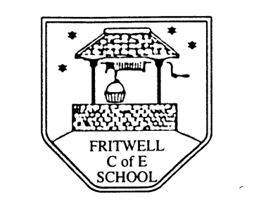
Breakfast Club Booking Form
Each session costs £5 and runs from 7.45-8.40am. Payment can be made by cheque (payable to Oxfordshire County Council) or cash. If you have more than one child please put them all on the same form and tick each day that you want to book.

Child’s Name: ………………………………………………………………………………………………………………. Date: ……………………………….
Summer Term 2 Tuesday 8th June to Thursday 22nd July Academic Year 2020-2021
DAY | Week  Beg  7th June | Week  Beg  14th June | Week  Beg  21st June | Week  Beg  28th June | Week  Beg  5th July | Week  Beg  12th July | Week  Beg  19th July
Monday

Tuesday

Wednesday

Thursday

Friday

Payment via ParentPay

