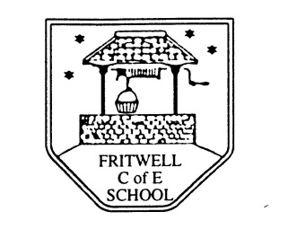
Part-time Breakfast Club Leader required for January 2019
Grade 1 Point 6 (16,394)
Actual Salary £1845
Would you like to be part of a caring and supportive school, where the children have outstanding attitudes to learning and the staff have high expectations to ensure all children reach their full potential? We are looking for an enthusiastic person to work 5 days per week 7.30-8.30am term time only
We can offer you:
- A nurturing learning environment where all are respected and valued
- Caring, well behaved and respectful children with positive attitudes to learning
- An opportunity to work as part of an effective and supportive team
- A commitment to staff training and development
We are looking for someone who
- Is committed to ensuring an excellent standard of education for all our children
- Will be committed to the Christian ethos of our school
- Enjoys working in collaboration with other staff, teachers and the wider partnership of schools
- Will adhere to our safeguarding policy
- Is willing to undertake any necessary training such as First Aid and Food Safety
If you are interested please contact Val Latham in the school office on 01869 345283 or email office.3065@fritwell.oxon.sch.uk
To apply please fill in the Oxfordshire Support Staff Application Form and email to the school office.
Deadline for applications:

