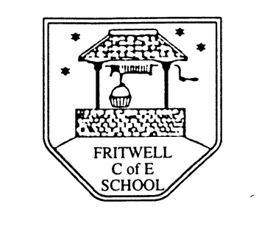
Breakfast Club Booking Form
Each session costs £5 and runs from 7.30-8.30am, your child can arrive at any point within that hour. If possible please enter your booking requirements per half term, so that we can plan staffing requirements. Payment can be made preferably by cheque (payable to Oxfordshire County Council), or if necessary with cash. If you have more than one child then please fill in one booking form per child. Tick each day that you want to book.
Child’s Name: …………………………………………………. Class: ……………………… Date: ……………………………….
Autumn Term 2 Tuesday 5th November to Thursday 19th December Academic Year 2019-2020
DAY | Week  Beg  4th Nov | Week  Beg  11th Nov | Week  Beg  18th Nov | Week  Beg  25th Nov | Week  Beg  2nd Dec | Week  Beg  9th Dec | Week  Beg  16th Dec
Monday

Tuesday

Wednesday

Thursday

Friday

Total Payment enclosed £ ……………………….. cash/cheque (payable to Oxfordshire County Council)

