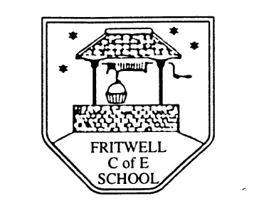
Breakfast Club Booking Form
Each session costs £5 and runs from 7.45-8.40am. Payment can be made by cheque (payable to Oxfordshire County Council) or cash. If you have more than one child please put them all on the same form and tick each day that you want to book.

Child’s Name: ………………………………………………………………………………………………………………. Date: ……………………………….
Autumn Term 2 Monday 2nd November to Friday 18th December 2020 Academic Year 2020-2021
DAY | Week  Beg  2nd Nov | Week  Beg  9th Nov | Week  Beg  16th Nov | Week  Beg  23rd Nov | Week  Beg  30th Nov | Week  Beg  7th Dec | Week  Beg  14th Dec
Monday

Tuesday

Wednesday

Thursday

Friday

Payment to be made via ParentPay

