Dear Parent/ Carer September 2021
It has been a joy to welcome your child to our classroom. Whether your child is a returning Minnow or a new starter, they have all began their school journey in a brilliant way. We are all so impressed with how well the children have settled into their new school routine and the new responsibilities they have as Minnows and Tiddlers. It has been lovely to see so many smiling faces walk into our classroom every day. We hope the following information will help you and your child settle in to the routine of school and offer you insights into our school day.
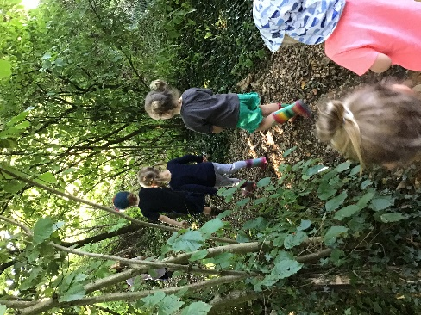
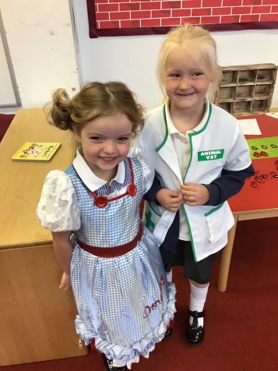

Water bottles and snacks:
Please remember to send your child in with a water bottle. If their bottles need refilling, this will be done by an adult with clean hands/ wearing gloves. All water bottles are kept in a tray for the children to access whenever they need to. Your child is welcome to bring a healthy snack to school which should be stored in their book bags. A fruit snack will also be provided by the school for any children who want it, however, we cannot always guarantee that your child will like the fruit on offer. If your child is registered with Cool Milk they will receive their carton of milk at snack time, in cases where the child does not want to drink their milk, the carton will be given to the child at the end of the day to take home.

PE Kit:
PE during this term is timetabled for Friday morning. Your child’s kit needs to be in school every day just in case these sessions change for any reason. Please ensure that they have navy blue shorts, t-shirt, trainers and appropriate warm clothing for going outside and that all items are clearly named. Tiddlers do not need to bring a PE kit to school as their PE will mostly be completed in our outdoor area. PE kits will be sent home on a Friday so that the cloakrooms can be thoroughly cleaned.

Tapestry:
All children are now active on Tapestry and you should be able to view and comment on all observations of your child. Please check your emails for the link to activate your account. Tapestry is a great way for you to see what your child has been doing at school all day and is a great tool for you to start conversations after school, you might get a better answer than ‘I can’t remember what I did’. Tapestry is also a great place for you to upload your own observations of your child. If they have made some wonderful creations at home, done something really helpful or been on a fantastic day out then please upload pictures and information onto Tapestry. These pictures can then be shared with the rest of the class during our ‘Tapestry Time’ on Thursdays.

Forest School
The children will have Forest School with Mr Pemble every Tuesday until the Christmas holidays. Please ensure that your child has appropriate clothing in their Forest School kit. As the term goes on the weather will be getting much colder and wetter so you may wish to consider packing waterproof overalls as part of their kit. It is important that your child has clothing that covers their arms and legs to protect them from any low hanging branches. Your child will also be expected to wear wellington boots to Forest School. We do have a welly rack in our outdoor space where children can leave their wellies at school. It is always useful for children to have access to their wellies at school so that they can play freely in the mud kitchen and be able to go outside in all weathers.

Classroom:
Our classroom is organised in areas that coincide with the Early Years curriculum. We have a construction area where children build models with a variety of construction materials, a reading corner with a selection of books, a writing and art table, Phonics area and a role play home area. Our outdoor space has plenty of opportunities for the children to explore their Physical Development; they can run, climb, ride bikes and build dens.

Reading:
It is important to share books with your child regularly and to talk about what you have read together. The reception children will soon begin their Phonics lessons where they will be taught to blend sounds together for reading. Children develop at different rates and so they will be given a reading book when we feel that they are ready. Once your child has received a reading book we encourage you to read with them every day. It does not always have to be your child reading aloud to you, it is as equally important for your child to listen to you read so you can share an enjoyment of books. Your child will bring home a reading record, we encourage you to write a comment about how well your child read that day.

Other information
- Mrs Blake will be teaching the children on Monday afternoons
- Our school day starts at 8:40 and ends at 3:10
- Ensure that your child’s uniform is clearly labelled, it makes it much easier to return belongings.

We are so pleased to be back at school and look forward to all the exciting things that lay ahead.
Miss Williams, Ms Fricker and Mrs Mooney.

