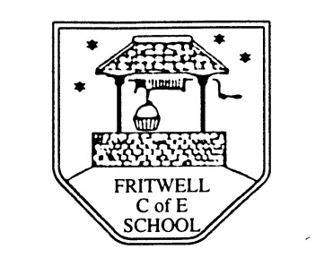
Breakfast Club Booking Form
Each session costs £5 and runs from 7.45-8.40am. Payment can be made by cheque (payable to Oxfordshire County Council) or cash. If you have more than one child please put them all on the same form and tick each day that you want to book.

Child’s Name: ………………………………………………………………………………………………………………. Date: ……………………………….
Summer Term 1 Monday 19th April to Friday 28th May Academic Year 2020-2021
DAY | Week  Beg  19th April | Week  Beg  26th April | Week  Beg  3rd May | Week  Beg  10th May | Week  Beg  17th May | Week  Beg  24th May
Monday

Tuesday

Wednesday

Thursday

Friday

Payment via ParentPay

