-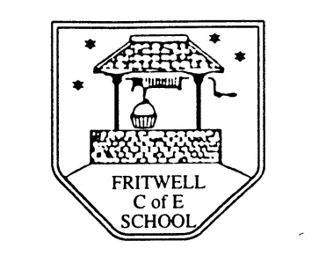
Breakfast Club Booking Form
Each session costs £5 and runs from 7.45-8.40am. Payment is to be made via ParentPay. If you have more than one child please put them all on the same form and tick each day that you want to book.

Child’s Name: ………………………………………………………………………………………………………………. Date: ……………………………….
Spring Term 1 Wednesday 5th January to Friday 18th February 2022 Academic Year 2021-2022
DAY | Week  Beg  3rd Jan | Week  Beg  10th Jan | Week  Beg  17th Jan | Week  Beg  24th Jan | Week  Beg  31st Jan | Week  Beg  7th Feb | Week  Beg  14th Feb
Monday

Tuesday

Wednesday

Thursday

Friday

