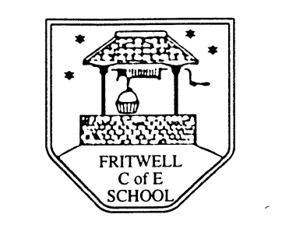
Breakfast Club Booking Form
Each session costs £5 and runs from 7.30-8.30am, your child can arrive at any point within that hour. If possible please enter your booking requirements per half term, so that we can plan staffing requirements. Payment can be made preferably by cheque (payable to Oxfordshire County Council), or if necessary with cash. If you have more than one child then please fill in one booking form per child. Tick each day that you want to book.
Child’s Name: …………………………………………………. Class: ……………………… Date: ……………………………….
Autumn Term Wednesday 4th September to Friday 25th October 2019 Academic Year 2019-2020
DAY | Week  Beg  2nd Sept | Week  Beg  9th Sept | Week  Beg  16th Sept | Week  Beg  23rd Sept | Week  Beg  30th Sept | Week  Beg  7th Oct | Week  Beg  14th Oct | Week  Beg  21st Oct
Monday

Tuesday

Wednesday

Thursday

Friday

Total Payment enclosed £ ……………………….. cash/cheque (payable to Oxfordshire County Council)

