-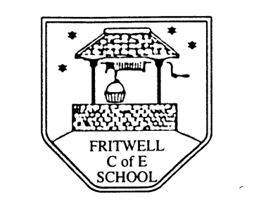
Breakfast Club Booking Form
Each session costs £5 and runs from 7.45-8.40am. Payment is to be made via ParentPay. If you have more than one child please put them all on the same form and tick each day that you want to book.

Child’s Name: ………………………………………………………………………………………………………………. Date: ……………………………….
Summer Term 2 Tuesday 7th June to Tuesday 19th July 2022 Academic Year 2021-2022
DAY | Week  Beg  6th June | Week  Beg  13th June | Week  Beg  20th June | Week  Beg  27th June | Week  Beg  4th July | Week  Beg  11th July | Week  Beg  18th July
Monday

Tuesday

Wednesday

Thursday

Friday

