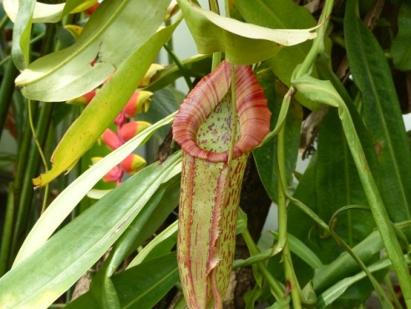

**Homework will continue to be sent home on a Tuesday, and should be completed by the following Monday.**

**Please ensure that named P.E. kit is sent into school on a Monday, to be kept in school for the whole week. NB Many items of clothing are coming into school without names in, and we are accumulating lots of lost items – please make sure that your child’s clothing is clearly name labelled.**

***Thanks for your support with this – Mr. Sear*Homework will be sent out on a Tuesday and needs to returned on the following Monday. MyMaths online / Spellings (writing sentences) and Times Tables.  
  
Please have named PE kit in school from Mon to Fri every week.Homework will be sent out on a Tuesday and needs to returned on the following Monday. MyMaths online / Spellings (writing sentences) and Times Tables.  
  
Please have named PE kit in school from Mon to Fri every week. Homework will be sent out on a Tuesday and needs to returned on the following Monday. MyMaths online / Spellings (writing sentences) and Times Tables.  
  
Please have named PE kit in school from Mon to Fri every week.**

This term the children will be working on the book ‘Journey To The River Sea’ by Eva Ibbotson, which is set in the Amazon around one hundred years ago. They will also be making masks inspired by the people of the rainforest. In Science we will be looking at living things and their habitats, using our own environment and comparing it with the Amazon. We are taking part in the Royal Horticultural Society’s ‘Rocket Science’ project, and will be carefully monitoring the progress of 200 rocket seeds over the next few weeks. Towards the end of the term we are planning to design and make food based on Brazilian, English and French dishes. I will be sending a letter out asking for a small voluntary contribution to cover the cost of this. Many thanks in advance.

**Our Topic for this term is Amazon Adventure. The children will be finding out more about the amazing people, plants and animals that live there, and they will be creating their own Amazon Survival Guide, which will be brought home at the end of term.**

Homework will be sent out on a Tuesday and needs to returned on the following Monday. MyMaths online / Spellings (writing sentences) and Times Tables.  
  
Please have named PE kit in school from Mon to Fri every week.**Class Five – Summer 2016**