Friends of Fritwell School Newsletter
Welcome to FoFS Christmas newsletter. I can’t believe how fast the year is going! Only this week of term left and then it’s countdown to the big jolly fellow visiting us on Christmas Eve and probably a very early morning on Christmas Day for most of us.
We have had a great term with three of our main events taking place, starting with Fireworks Night, followed by the Secret Present Room, which all the children, teachers and volunteers seem to love, and then we held the Christmas Disco.
Fireworks Night

What another great Friends of Fritwell School event and this is all down to you! You raised over £1700 for the school which is fantastic.
This would not have been possible without the fantastic help from the bonfire build team, the Sunday set up team, donations of wood from Will Blake, Mike Wheeler and hay bales from Helen Baker, Rob Jones on lighting and sound, Carl Hynes for MC’ing, Wrightons of Fritwell for a great BBQ as usual and all the FoFS team and stall volunteers.
Thank you again to everyone.
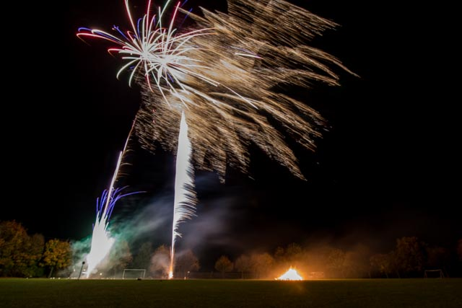

Secret Present Room

This took place last week after all the hard work of Petra Turner and Jo Beeney for organising and shopping for all the lovely gifts you are all eagerly anticipating. The children come along to the sale and choose gifts for family members which are then wrapped and labelled for them to take home to put under the Christmas Tree.

What a great morning we all had, with the help of the Sharks assisting all the other classes with choosing, wrapping and writing of labels.

This event raised over £450 with some monies still to come in, so thank you to everyone who donated gifts which makes this event possible along with the support from the helpers on the day.

Disco Fever

Following on from the Secret Present room, if that wasn’t enough excitement, Anna Simpson and Louise Vaughan with helpers, ran the school disco for the Lower School from 5pm until 6pm and the Upper School from 6.15pm –
7.30pm. Thank you to all helpers for running this event.

Next term we have Bingo Evening to look forward to and our annual Easter Egg Hunt.
Dates for your dairy (dates may change subject to other school commitments)
- Friday 3rd February – School Bingo Night
- Saturday 1st April – Easter Egg Hunt
- Friday 7th July – Party in the Playground
Summer Event

Plans are coming along for the Summer Event, marquee and children’s entertainment and MC for the evening are booked.

We have already gained a small sponsorship from Viridor Charitable Donation Committee of £100, £200 from Roger Mackrell Carpentry for the Children’s Entertainer and £200 from Smiths of Bletchingdon to cover cost of programme printing .

We are looking for sponsorship for a list of items if you can help or know of anyone who might be able and willing to sponsor this event.

Marquee –
Flooring –
Bar Equipment –
Generator –
Sound Equipment –

So, I believe that is it for now, but if you want to keep up to date on what we are up to, why not have a look at our Facebook page ‘Friends of Fritwell School’ which has news of all our events.

Committee 2016/17
- Chair – Stephanie Hicks
- Vice Chair – Kate Akkerman
- Treasurer – Helen Jones
- Secretary – Carly Dayus
- School liaison – Rachel Chadbourne
- Ordinary committee members: Petra Turner, Jo Beeney, Katie Hunter, Diane Fricker, Fiona Mills
- Parent volunteers: Angus Lyon, Jen Lyon, Kay Bishop, Caz Blake

Regards

Stephanie Hicks
Chairperson

