Seahorses - Curriculum Newsletter – Spring 2018
Dear Parents and Carers
Happy New Year, welcome back to school and we hope you had a lovely break.
Our Topic for this term is: Fantastic Fritwell
This term we will be finding out about life in the local area, and focussing on Children in Wartime, Evacuees and World War Two.
English:
The children will be reading a number of different texts related to our Children in Wartime topic, and then writing stories, letters, diaries, and newspaper articles based on these. N.B. Year 2 and Year 3 children will usually work in mixed groups for English, but we will ensure that tasks are appropriately differentiated for age and level of challenge.
Maths:
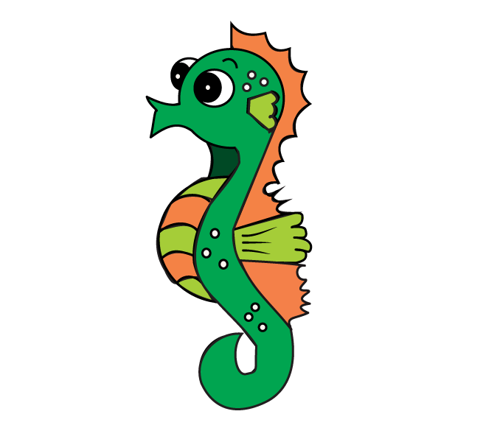
This term we will be looking at: number and place value, mental addition and subtraction, problem solving, measuring, geometry, position and direction. Year 3s will also be working on fractions, ratio and proportion. N.B. Year 2 and Year 3 children will be following the programme of study for their year, with appropriately differentiated work to support and challenge where needed.
RE: Islam.
PE: Invasion games and Dance.
Music: Singing and tuned percussion skills.
Science: Friction, magnetism, light and shadows.
Homework will continue to be set every Tuesday to be returned on the following Monday. Also, please read with your child as frequently as you are able, and practise relevant times tables.
Please ensure that your child has the correct P.E. kit in school from Monday to Friday, and that all items of clothing are clearly labelled with their name.
Mr. Sear will be teaching the class on Mondays, Tuesdays, Thursday mornings and Fridays, and Mrs. Rowe will be teaching the class on Wednesdays and also Thursday afternoons.

If you have any questions, please feel free to contact us.

Many thanks and best wishes,
Mr Adam Sear Mrs. Zoe Rowe

