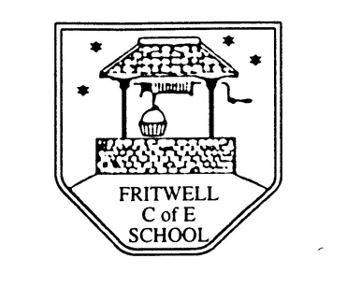
Breakfast Club Booking Form
Each session costs £5 and runs from 7.45-8.30am, your child can arrive at any point within that hour. If possible please enter your booking requirements per half term, so that we can plan staffing requirements. Payment can be made preferably by cheque (payable to Oxfordshire County Council), or if necessary with cash. If you have more than one child then please fill in one booking form per child. Tick each day that you want to book.
Child’s Name: …………………………………………………. Class: ……………………… Date: ……………………………….
Spring Term 2 Monday 24th February to Friday 3rd April Academic Year 2019-2020
DAY | Week  Beg  24th Feb | Week  Beg  2nd Mar | Week  Beg  9th Mar | Week  Beg  16th Mar | Week  Beg  23rd Mar | Week  Beg  30th Mar | END OF  SPRING  TERM
Monday

Tuesday

Wednesday

Thursday

Friday

Total Payment enclosed £ ……………………….. cash/cheque (payable to Oxfordshire County Council)

