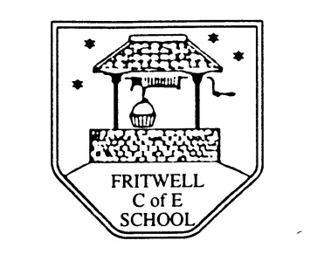
Breakfast Club Booking Form
Each session costs £5 and runs from 7.30-8.30am, your child can arrive at any point within that hour. If possible please enter your booking requirements per half term, so that we can plan staffing requirements. Payment can be made preferably by cheque (payable to Oxfordshire County Council), or if necessary with cash. If you have more than one child then please fill in one booking form per child. Tick each day that you want to book.
Child’s Name: …………………………………………………. Class: ……………………… Date: ……………………………….
Summer Term 1 Tuesday 4th June to Tuesday 23rd July Academic Year 2018-2019
DAY | Week  Beg  3rd June | Week  Beg  10th June | Week  Beg  17th June | Week  Beg  24th June | Week  Beg  1st July | Week  Beg  8th July | Week  Beg  15th July | Week  Beg  22nd July
Monday

Tuesday

Wednesday

Thursday

Friday

Total Payment enclosed £ ……………………….. cash/cheque (payable to Oxfordshire County Council)

