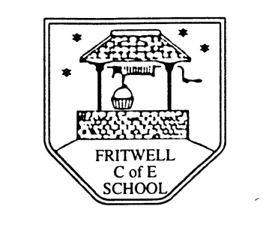
Breakfast Club Booking Form
Each session costs £5 and runs from 7.30-8.30am, your child can arrive at any point within that hour. If possible please enter your booking requirements per half term, so that we can plan staffing requirements. Payment can be made preferably by cheque (payable to Oxfordshire County Council), or if necessary with cash. If you have more than one child then please fill in one booking form per child. Tick each day that you want to book.
Child’s Name: …………………………………………………. Class: ……………………… Date: ……………………………….
Term 2 30 Oct-19 December Academic Year 2017-2018
DAY | Week  Beg  30Oct | Week  Beg  6 Nov | Week  Beg  13 Nov | Week  Beg  20 Nov | Week  Beg  27 Nov | Week  Beg  4 Dec | Week  Beg  11 Dec | Week  Beg  18 Dec
Monday

Tuesday

Wednesday |  |  |  |  |  |  |  | Hols
Thursday |  |  |  |  |  |  |  | Hols
Friday |  |  |  |  |  |  |  | Hols

Total Payment enclosed £ ……………………….. cash/cheque (payable to Oxfordshire County Council)

