**C:\Users\rachel.chadbourne.F2T-FRITWELL.001\AppData\Local\Microsoft\Windows\Temporary Internet Files\Content.IE5\SNY9PMCI\MC900232723[1].wmfSummer - Term 5 and 6 – Year 4 Parent Newsletter**

**Dear Parents,**

We are looking forward to a term full of activity, learning and great progress.

[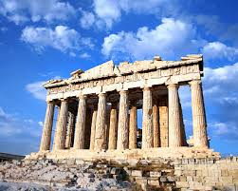](http://www.google.co.uk/url?sa=i&rct=j&q=&esrc=s&source=images&cd=&cad=rja&uact=8&ved=0CAcQjRw&url=http://www.destination360.com/europe/greece/acropolis&ei=gckuVbPaN47hasWOgOAK&bvm=bv.90790515,d.d2s&psig=AFQjCNEmAdPgqcjsgNovY2sVo0yY3b2AQA&ust=1429215983318318)

**Curriculum**Our topic this term is called “Myths and Monsters” and we will be learning about the Ancient Greeks and Greek mythology. We are looking forward to our ‘Cheering on the Greeks’ workshop on Tuesday 3rd May when we hope to find out lots about the Olympic Games and have the opportunity to look at artefacts and historical sources. In science, our unit of work is ‘Sound’. We will be finding out how we hear sounds, how sound can be muffled and how pitch and volume can be altered.

**PE**  
PE will now be on Wednesdays and Fridays. Your child’s kit needs to be in school every day just in case these sessions change for any reason. Please make sure that they have navy blue shorts, t-shirt, trainers and appropriate warm clothing for going outside as we may still have some cold days. Feel free to take your child’s kit home on a Friday if it needs washing but do please remember to send it back in on a Monday.

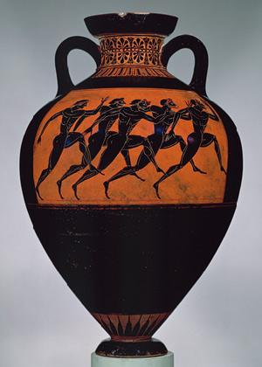**Homework**This is unchanged from last term. Homework is set on a Tuesday and due in the following Monday. Children will be set one piece of English, which may be spellings, one piece of maths and an activity to practise, either times tables or number bonds. We will still be using the Times Table booklets so please continue to encourage your child to practise their tables at home and ask to be tested at school so they can earn their bronze, silver and gold awards.

As always, if you have any questions please get in touch.

Thank you for your continued support.

[](http://www.google.co.uk/url?sa=i&rct=j&q=&esrc=s&source=images&cd=&cad=rja&uact=8&ved=0CAcQjRw&url=http://galleryhip.com/theater-masks-comedy-tragedy.html&ei=rdAuVYrhJofXauHHgPAF&bvm=bv.90790515,d.d2s&psig=AFQjCNGaxxHMTD9eimn9IuEyw09QJshHtA&ust=1429217804991289)Best wishes,  
Jo Ejiogu and Jane Leaver