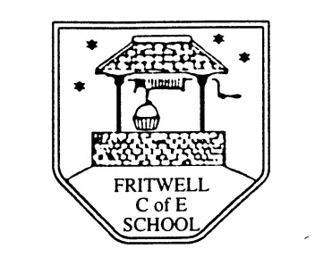
Breakfast Club Booking Form
Each session costs £5; if possible please enter your booking requirements for a full term, so that we can plan staffing requirements. Payment can be made preferably by cheque (payable to Oxfordshire County Council), or if necessary with cash. If you have more than one child then please fill in one booking form per child. Tick each day that you want to book.
Child’s Name: …………………………………………………. Class : ……………………… Date: ………………………………….
Term 6 Academic Year 2014-2015
DAY | Week Beg  1 June | Week  Beg  8 June | Week Beg  15 June | Week  Beg  22 June | Week  Beg  29 June | Week  Beg  6 July | Week  Beg  13 July
Monday

Tuesday

Wednesday

Thursday

Friday

Total Payment enclosed £ cash/cheque (payable to Oxfordshire County Council)

