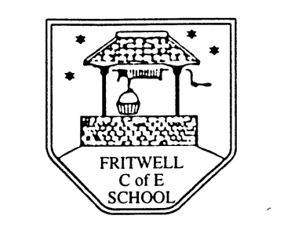
Breakfast Club Booking Form
Each session costs £5 and runs from 7.30-8.30am, your child can arrive at any point within that hour. If possible please enter your booking requirements per half term, so that we can plan staffing requirements. Payment can be made preferably by cheque (payable to Oxfordshire County Council), or if necessary with cash. If you have more than one child then please fill in one booking form per child. Tick each day that you want to book.
Child’s Name: …………………………………………………. Class: ……………………… Date: ……………………………….
Spring Term 1 Monday 6th January to Friday 14th February Academic Year 2019-2020
DAY | Week  Beg  6th Jan | Week  Beg  13th Jan | Week  Beg  20th Jan | Week  Beg  27th Jan | Week  Beg  3rd Feb | Week  Beg  10th Feb | HALF  TERM
Monday

Tuesday

Wednesday

Thursday

Friday

Total Payment enclosed £ ……………………….. cash/cheque (payable to Oxfordshire County Council)

