All about Me/ Robots
Termly homework project- Due in on Friday 12th November.
The children are asked to complete at least one activity from the list below, if your child would like to do more they can! Your child can present their homework any way they would like, the more creative the better! Your child will get the chance to share their homework with the rest of the class. I can’t wait to see what your child comes up with.
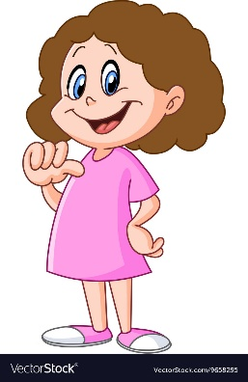  In our Topic ‘All about Me’ we are going to learn about how we are all different and unique. With help from your grown up could you create a Fact File all about your favourite things. You could write about your favourite colour, food, game or write a special fact about yourself. | Talk to someone at home about what you would like to do when you grow up. Try and find out a little bit more about it by talking to people who know about that role or looking in a book or on the Intern et.
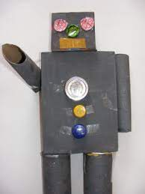  During the second half of Autumn term we will be learning about Robots. Using a variety of junk modelling resources, could you build your own robot? Think about how big or small you want your robot to be and will it be able to help you complete any jobs. | 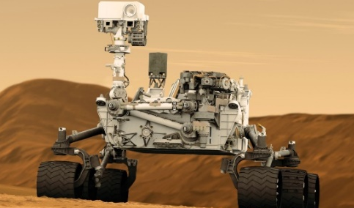  Robots can help us complete many jobs from farming to housekeeping. We even have robots in space. If you could create your own robot, what would it do? It might help with the hoovering, driving a car or work on the moon, the possibilities are endless. Be as creative as you like!

