Our Wonderful World/ Transport
Termly homework project- Due in on Friday 25th March
The children are asked to complete at least two activities from the list below, if your child would like to do more they can. Your child can present their homework any way they would like, the more creative the better! Projects can be brought into school or pictures can be uploaded to Tapestry where your child will get the chance to share their homework with their class. I can’t wait to see what your child comes up with.
We have been learning about animals that live in different habitats and climates. Can you research an animal from a different climate, maybe an animal who lives somewhere very cold or very hot, and write a short fact file about the animal. | Different countries around the world created some of our favourite meals. Pizza was created in Italy, fish and chips in England and crepes in France. With help from your grown-up can you cook a meal that was created in a different country? Homemade pizza anyone? Take a picture of your dish and put it on Tapestry. I hope it tastes good!
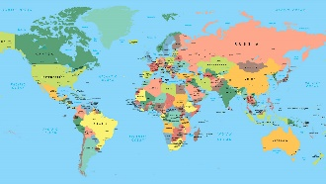  We are learning about life in Africa and soon will beginning learning about life in Antarctica. Can you research a different country and find out what life is like there? If you have been on holiday to a different country then maybe you could find out about that. | In our Transport topic we will find out about different modes of transport from the past and present. Can you design a futuristic vehicle? You may want to make it out of junk modelling or draw it on a large piece of paper. Make your vehicle as creative as possible, maybe you want to create the first flying car or a rocket that can take you to school.
Have you ever been on an exciting journey? Maybe you went on an aeroplane to go on holiday or a long car journey to go to the zoo. Can you tell me about this exciting journey? You could draw a picture of your journey, film a video of you talking about it or try and write a short sentence. | 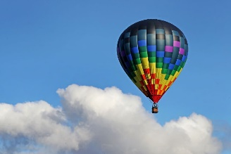  Hot Air Balloons were invented a very long time ago and people still use them today. Can you use your imagination to create your own hot air balloon adventure? Think of a creative way to tell me your story.

