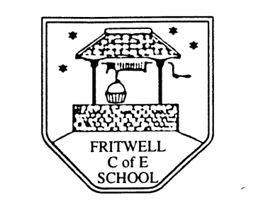
Breakfast Club Booking Form
Each session costs £5 and runs from 7.40-8.40am, your child can arrive at any point within that hour. If possible please enter your booking requirements per half term, so that we can plan staffing requirements. Payment can be made preferably by cheque (payable to Oxfordshire County Council), or if necessary with cash. If you have more than one child then please fill in one booking form per child. Tick each day that you want to book.
Child’s Name: …………………………………………………. Class: ……………………… Date: ……………………………….
Term 5 24 April-26th May Academic Year 2016-2017
DAY | Week Beg  24 April | Week  Beg  1 May | Week Beg  8 May | Week  Beg  15 May | Week  Beg  22 May
Monday |  | Bank  Holiday
Tuesday

Wednesday

Thursday

Friday

Total Payment enclosed £ ……………………….. cash/cheque (payable to Oxfordshire County Council)

