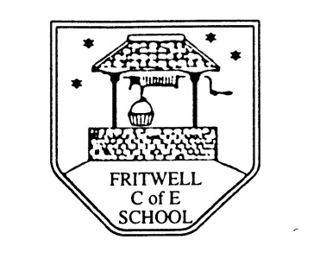
Breakfast Club Booking Form
Each session costs £5 and runs from 7.30-8.30am, your child can arrive at any point within that hour, but not before 7.30 please. If possible please enter your booking requirements per half term, so that we can plan staffing requirements. Payment can be made preferably by cheque (payable to Oxfordshire County Council), or if necessary with cash. If you have more than one child then please fill in one booking form per child. Tick each day that you want to book.
Child’s Name: …………………………………………………. Class: ……………………… Date: ……………………………….
Term 6 Tues 5th June to Wed 25th July Academic Year 2017-2018
DAY | Week  Beg  4th June | Week  Beg  11th June | Week  Beg  18th June | Week  Beg  25th June | Week  Beg  2nd July | Week  Beg  9th July | Week  Beg  16th July | Week  Beg  23rd July
Monday | Inset
Tuesday

Wednesday

Thursday

Friday

Total Payment enclosed £ ……………………….. cash/cheque (payable to Oxfordshire County Council)

