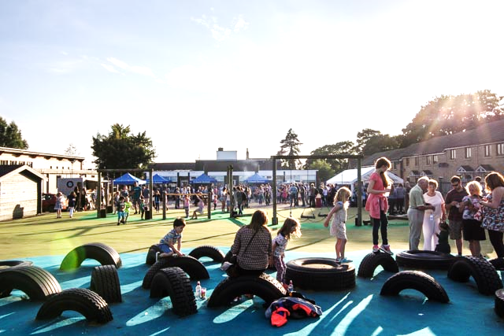
Friends of Fritwell School Newsletter- April 2017

Committee Members: Stephanie Hicks, Kate Akkerman, Carly Dayus, Jo Beeney, Helen Jones, Diane Fricker, Katie Hunter, Fiona Mills, Petra Turner

UPCOMING EVENTS
Party in the Playground – Friday 7th July
Following on from the success of the Summer Fete last year, we wanted to do something a little different!
It will be a great night of entertainment with ‘The Great Deep’ playing a selection of popular hits from the last four decades, they are guaranteed to get your feet stomping and your hands in the air. Made up of Fritwell talent with one or two guests!

We have a children’s show with Arron Williams, funfair rides and lots of food and drink. Even the weather can’t spoil the fun as this will all take place in a marquee so come rain or shine, we can party!

Tickets go on sale on Friday 7th April so look out for our ‘Early Bird Offers’ available until the 5th May which could save you up to 25% off on the gate price.

Early Bird Price  Available until 5th May | £
Early Bird Adult | 6.00
Early Bird Child (3yr to 16yr) | 5.00
Early Bird Family | 20.00

Standard Ticket Price | £
Adult | 7.50
Child | 5.50
Family | 24.00

Gate Price | £
On-Gate Adult | 8.50
On-gate Child | 6.50
On-gate family | 28.00

We are looking for sponsorship for this event because the more we can get sponsored, the more we can raise for FoFS. If you can help, know of anybody or a company who may be willing to help with any of the following, please contact us via our Facebook page.

We require:-

Marquee with nature flooring
Electrical cables with sockets etc.
Leaflet printing
Poster printing
Table cloths
Straw Bales
Stock for Pimms/Prosecco Bar
Soft Drinks
Radio Advertising

Already sponsored: -

Hire of a generator by Agrivert , Children’s entertainer by Roger Mackrell Carpentry , Programme Printing by Smiths of Bletchington and the stage by Oxfordshire Narrowboats

Nearer the time, we will be looking for a team of volunteers to help run the event so if you can help with this please let us know by contacting a member of the committee or via our Facebook page. Areas which will need covering are marshalling, stall running, technical team, man with a van, setting up team on the Friday (day time) taking down team on the Saturday.

We are having a meeting on Tuesday 16th May in The White Lion in Fewcott at 8pm so if you can help, volunteer or have any thoughts on the event please come along and join us for a drink.

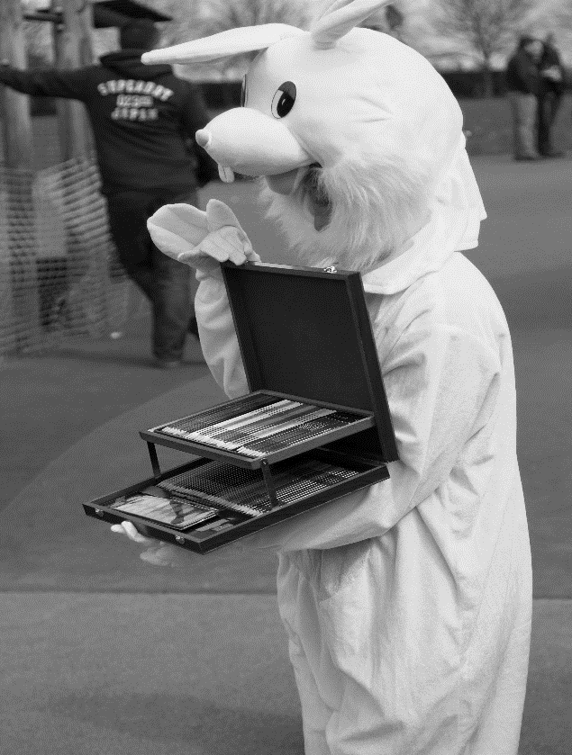
We hope this will be a great event to end the
school year and that you can all come along.
Keep an eye on our Friends of Fritwell Facebook page for more information and details.

School Disco – Thursday 13th July

Always very popular with the children as it is a chance to dress up in their best party outfits and enjoy an evening with their friends.

Lower school disco – 5pm to 6pm

Upper school – 6.15pm – 7.30pm
£1.50 entry free
Tuck shop and drinks available

NEWS

So, since the last newsletter we have had two more FoFS events, the Prize Bingo and the Easter Egg Hunt which were both great fun and very successful.

Prize Bingo

Bingo was a fun evening with lovely food from Fresh Start who we must say thank you to for their support and for going that extra mile.

Thank you to everyone who came along and we hope you won some lovely prizes. The evening raised over £200

Easter Egg Hunt

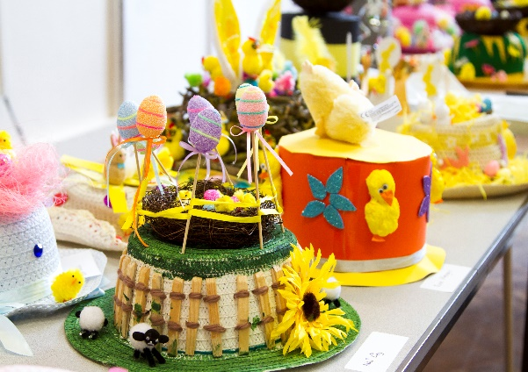

As many of you will know, we have just enjoyed the annual Easter Egg Hunt on Saturday. The weather was mostly kind to us. The Easter Bunnies did a marvellous job of entertaining the crowds and running races. PRP Catering served some great food and we would like to say thank you for supporting our event.

We would firstly like to say a huge thank you to all involved with the event, setting up, running stalls, and packing away. It wouldn’t be possible without the support of parents, teachers and the FoFS committee. And finally, thank you to all of you that come along and hunted for Eggs (well stones which turned into eggs)

We would like to say congratulation to Amber Dayus Year 4, for finding the Crystal Egg. Our winner of the Easter Hat competition was Rowan O’Neil, Foundation Stage and he won the Art Colouring set.

The event raised over £1200

New Committee

If you feel you would like to be involved with FoFS then we will be having our AGM in September so come along and see what we are all about. The committee will be looking for new members as a few of the current committee will be stepping down.

If you want more information, please contact any of the committee or talk to Mrs Chadbourne.

Once again, thank you for your support with all FoFS events.

We hope you all have a great Easter and enjoy the break and we will see you all next term.

Happy Easter

Kind Regards

Friends of Fritwell School

