-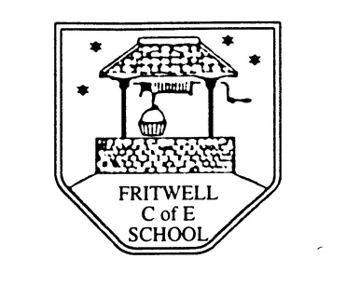
Breakfast Club Booking Form
Each session costs £5 and runs from 7.45-8.40am. Payment is to be made via ParentPay. If you have more than one child please put them all on the same form and tick each day that you want to book.

Child’s Name: ………………………………………………………………………………………………………………. Date: ……………………………….
Summer Term 1 Monday 25th April to Friday 27th May 2022 Academic Year 2021-2022
DAY | Week  Beg  25th Apr | Week  Beg  2nd May | Week  Beg  9th May | Week  Beg  16th May | Week  Beg  23rd May
Monday

Tuesday

Wednesday

Thursday

Friday

