Drip, Drip Drip!
Termly homework project – Due in 14th November to be shared throughout the week with the class!
Below is a selection of activities for you to complete independently over the next few weeks. You can present these activities however you like: on a big sheet of paper, in a folder, as a PowerPoint, in a book or electronically via Teams or sending an e mail to homelearning@fritwell.oxon.sch.uk – be as creative as you like. We are hoping that you will complete at least 3 of the activities. For those of you who are going on the residential trip to Kilvrough, there is an extra choice of tasks, linked to our trip. It would be great if you chose this one to share with the rest of Stingrays to show what a great experience it was. Enjoy!
Stop! Do you find you need more baths than normal? Is your stink getting the better of you? It is your opportunity to design and create a new bath bomb range…. Find out which materials are needed, make it smell pleasant and then watch it change state when you add water to it!  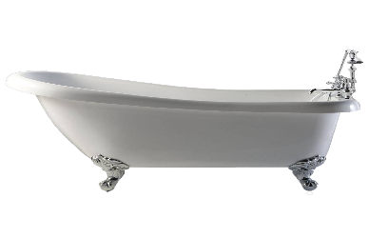  This Photo by Unknown Author is licensed under CC BY-NC | Our stories are taking us to some wonderful islands. If you got castaway on an island how would you survive? What are the dangers you face? Can you use as much imagination as possible to create your island hideout?  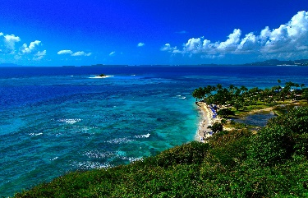 | Tell us about what you are going to take on your island that you think you wouldn’t be able to live without (not food, family or friends!) Pick 5 things and explain why you have chosen them and why they are so important to you (e.g book, teddy?)  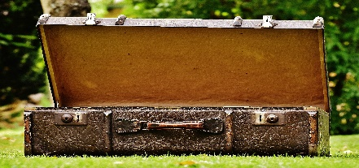
Mathematicians you are needed in a challenge that is of epic proportions!!! Using your world knowledge can you find out the lengths of the great rivers and lakes of this world? Compare and contrast the lengths and possible widths of  the water on Earth.  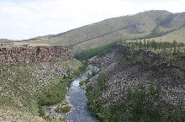  This Photo by Unknown Author is licensed under CC BY-SA | Claude Monet used water in some of his famous artwork. Find out about the artist and perhaps recreate a famous water painting using your own unique style.  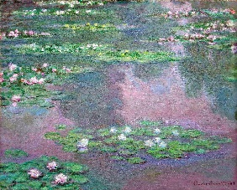  This Photo by Unknown Author is licensed under CC BY | 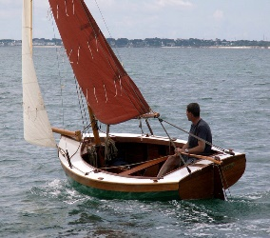  Design and create your own boat to help you escape from your island. Try to use recycled materials in your construction. Think about what is needed on your boat to help you navigate and survive your journey.  This Photo by Unknown Author is licensed under CC BY

Kilvrough!
For the Year Stingrays, I am sure that the highlight of the term will be our trip to Kilvrough. How can you record your experience to help you remember it and share it with your family?

Would you like to write a diary about the trip? You could use photos to present this as a photo power point or video.

Could you produce a set of instructions about how to do one of the activities you enjoyed at Kilvrough?

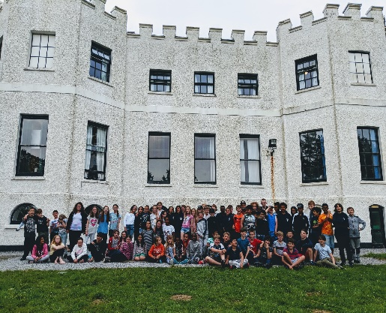
Or write a letter to next year’s Stingrays sharing top tips for how to enjoy a residential.

