Fire and Ice!
Termly homework project – Due in on Monday 15th December, to be shared on Wednesday 17th December.

Below is a selection of activities for you to complete independently over the next few weeks. You can present these activities however you like: on a big sheet of paper, in a folder, as a PowerPoint, in a book – be as creative as you like. Enjoy!
Make an apron for a baker.  What materials will you use? | 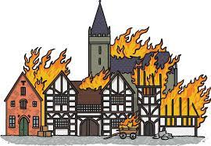  Write a short description of the Great Fire of London.  What describing words can you include? | 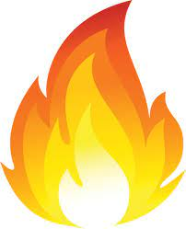  Create a fire safety poster. How can people stay safe around fire? What do they need to remember?
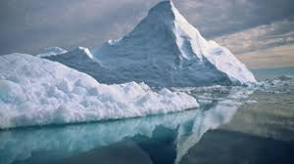  Create a polar environment picture using any crafts you want. | 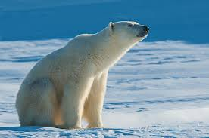  Find out some facts about Arctic and Antarctic animals and draw them. | 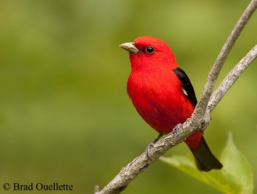  Research some birds that migrate in winter and find out where they fly to

