Dear Parent/ carer April 2022

Welcome back! It has been wonderful having your child back in class following the Easter holiday and it was lovely getting to see you all again during drop off and pick up. I hope you all had an enjoyable break. We were very lucky to have some sunshine at the beginning of the week which really helped boost the positivity of the children and help them settle back into the routines of school.
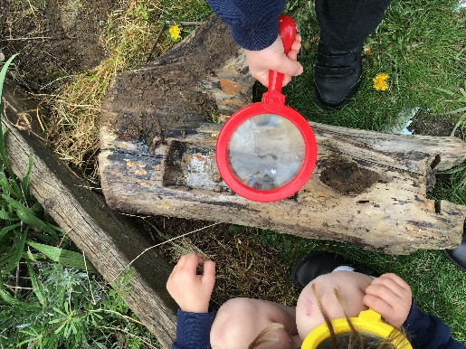
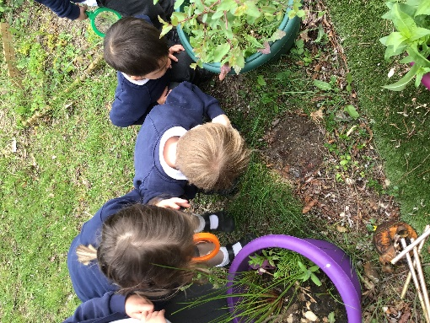
Topic
Our Topic this half term is Minibeasts. We kicked off our new Topic this week by reading The Ugly Bug Club and going on a minibeast hunt around school. During this topic we are going to learn about the life cycle of a butterfly using the text The Very Hungry Caterpillar and learning about the similarities and differences of snails and slugs using the text The Snail Trail. This Topic has links to the EYFS curriculum area of Understanding the World and through this topic I am hoping to instil in your child a curiosity about the natural world around them, an understanding of growth and changes over time and a desire to look after all living things. After the May half term holiday, our Topic will be Heroes. During this topic the children will learn about people who help us, characteristics that make someone a ‘hero’ and to discover all the different ways we could be heroes in our everyday life. This topic has links to the EYFS curriculum area of Understanding the World through exploring the lives of people around us and also to Personal, Social and Emotional Development by encouraging your child to see the characteristics they have which makes them special and brave and to begin to prepare them for their school transition in the Autumn. The books we will be reading during this Topic are Supertato, Real Superheroes, and Superkid.

Belongings
We try to ensure that all children in Minnows and Tiddlers take responsibility for their own belongings, this includes carrying their belongings to and from the classroom. To help your child manage this please send them in with the minimal amount of belongings as possible. The only necessary belongings are water bottle, fruit or vegetable snack, sun hat, lunch box (unless school dinner) and spare clothes, the warmer weather increases our use of the water tray which often results in wet clothes so even if your child is unlikely to have a toilet accident, spare clothes are still a necessity. Once the weather has warmed up, please remember to apply sun cream to your child before school and pack a spare bottle in your child’s book bag. Your child will have to apply the sun cream themselves at school so please help your child gain independence in this by letting them practice at home.

PE Kit
PE during this term is timetabled for Wednesday morning. Your child’s kit needs to be in school every day just in case these sessions change for any reason. Please ensure that they have navy blue shorts, t-shirt, trainers and appropriate warm clothing for going outside and that all items are clearly named. Tiddlers do not need to bring a PE kit to school as their PE will mostly be completed in our outdoor area. PE kits will be sent home after the PE lesson and do not need to be returned to school until the following week.

Water bottles and snacks
Please remember to send your child in with a water bottle. All water bottles are kept in a tray for the children to access independently throughout the day, however, all children are reminded frequently to have some of their drink and are informed of the importance of staying hydrated. Your child is welcome to bring a healthy snack to school which will be stored in the snack box, a fruit snack will also be provided by the school for any children who want it. If your child is registered with Cool Milk they will receive their carton of milk at snack time, in cases where the child does not want to drink their milk, the carton will be given to the child at the end of the day to take home. Please check with your child if they would still like milk at school, we currently have many children refusing their milk during snack time.

Tapestry
We aim to upload regular observations of any wow moments or achievements your child has at school. It is a great way for you to see what your child has been doing at school all day and is a great tool for you to start conversations after school, you might get a better answer than ‘I can’t remember what I did’. Please contribute to your child’s tapestry observations, as the experiences your child has at home are invaluable to helping us know more about their achievements and successes. They are really useful for identifying learning that we may not have seen in school. We also have ‘Tapestry Tuesday’ where your child will be able to share with the class any observations you have uploaded. If you have any questions about accessing Tapestry or uploading observations then please let me know.

Reading
Starting next week, your child will swap their reading books on Mondays so please ensure their books are in their book bags ready to be swapped. Throughout the week, we will endeavour to listen to all the Reception children read and make a note in their reading record. Please continue to read at home with your child each day, and record this in their reading record books. As part of our Read, Write, Inc Phonics scheme the children are encouraged to develop a ‘Storytelling Voice’ where they can emphasise parts of the story, change their voice for different characters or adapt the volume or tone of their voice whilst reading a story. Children this age will develop a storytelling voice through repetition of texts so please try to encourage your child to read their book multiple times throughout the week, this will also help your child to develop fluency in reading.

Forest School
We are going to begin Forest School in Week 3 of this term, this will then continue until the summer holidays. We will be going to Forest School on Thursday afternoons so please make sure your child brings appropriate clothing to wear on this day. Ideal clothing would be anything waterproof or old clothes that you don’t mind getting muddy and clothing that covers their arms and legs. Children must have wellington boots. An email will be sent to confirm our start date and any other necessary information within the next week.

Other information:
- The school day begins at 8:40, please aim to be at the gate at the start time so your child can settle into the classroom before beginning our carpet session.
- Please ensure all of your child’s uniform is clearly labelled, children often leave their jumpers and cardigans laying around the classroom and we are much more likely to be able to return uniform to the right children if they are labelled.

We have such an exciting term ahead of us and I am so excited for it to begin.

Have a lovely weekend,

Miss Williams, Ms Fricker, Mrs Mooney, Mrs Kimber and Ms Allen

