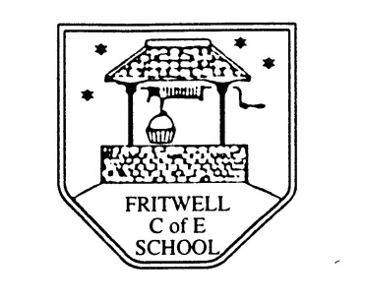
Breakfast Club Booking Form
Each session costs £5 and runs from 7.45-8.40am. Payment is to be made via ParentPay. If you have more than one child please put them all on the same form and tick each day that you want to book.

Child’s Name: ………………………………………………………………………………………………………………. Date: ……………………………….
Autumn Term 2 Tuesday 2nd November to Friday 17th December Academic Year 2021-2022
DAY | Week  Beg  1st Nov | Week  Beg  8th Nov | Week  Beg  15th Nov | Week  Beg  22nd Nov | Week  Beg  29th Nov | Week  Beg  6th Dec | Week  Beg  13th Dec
Monday

Tuesday

Wednesday

Thursday

Friday

