Dear Parent/ Carer January 2022

Welcome back! It has been a busy return to school for the Tiddlers and Minnows and an exciting beginning to their school journey for the new Tiddlers who have joined us. It was great to see how many of our returning children were able to remember the routines and rules of our classroom, and have taken pride in helping our new Tiddlers find their way.
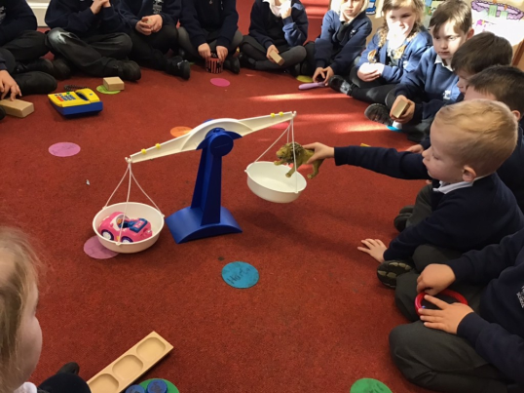

Topic
This term our Topic is Our Wonderful World. We have already started exploring what life is like in a hot country like Africa. To support us in our learning we have been reading ‘Handa’s Surprise’ which tells the story of Handa’s journey to her friend’s village. From this story we will be learning about African animals and the importance of healthy eating. After exploring Africa, we are going to make comparisons with a country with a colder climate, we will use the story ‘Immi’s Gift’ to help our explorations of Antarctica. We will find out about the animals that live in colder climates and how people stay safe in very cold weather. When we return after the February half term holiday we will be starting our Topic all about Transport. We will explore different modes of transport from past and present.

Tapestry
We love using Tapestry at school to share with you any amazing or fun things your child does during the day, the children will often ask us to take pictures of their creations to put on Tapestry for you to see. Every Tuesday we have ‘Tapestry Time’ where children are invited to the front of the carpet to share one of their Tapestry observations, to make this as engaging as possible, I ask that if you ever do any fun or exciting days out or if your child creates something wonderful at home then please take a picture and upload it to Tapestry for them to share during Tapestry Time. If you need help logging into Tapestry or uploading your own observations then please let me know and I can help you in any way I can.

Reading and Phonics
We follow the Read, Write, Inc Phonics and reading scheme and use their assessments and progression tools to ensure that children are making good progress. Last term our Phonics focus was teaching the children to read single-letter Set 1 sounds and blend sounds into words orally. Our goal for this long term is to blend sounds to read words, starting with the Ditty stories and eventually moving to the Red Storybooks. Please note that your child will need to be able to read all Set 1 single sounds before they can move to Ditty stories, this is monitored through regular assessments. Once your child is confidently reading at school they will start bringing Book Bag Books home, these are books from the Read, Write, Inc scheme and have been matched to their ability and should be fully decodable for your child. Your child will also bring home a shared reading book and library book for you to read together. These will be changed weekly. In addition to these books, please make the most of our subscription to Oxford Owl where you will find a range of eBooks to share with your child.
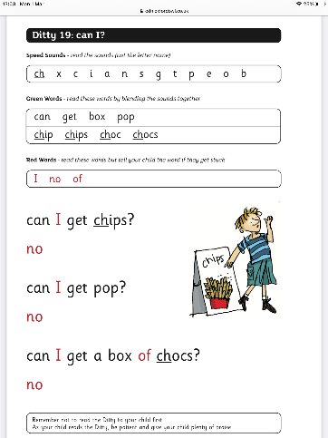

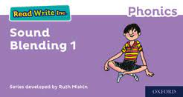

Snack/ water bottle
Please remember to send your child in with a water bottle. If their bottles need refilling, this will be done by an adult with clean hands/ wearing gloves. All water bottles are kept in a tray for the children to access whenever they need to. Your child is welcome to bring a healthy snack to school which should be stored in their book bags. A fruit snack will also be provided by the school for any children who want it, however, we cannot always guarantee that your child will like the fruit on offer. If your child is registered with Cool Milk they will receive their carton of milk at snack time, in cases where the child does not want to drink their milk, the carton will be given to the child at the end of the day to take home.

Cold Weather Wear
As the weather continues to get colder please ensure that your child has the appropriate clothing at school; hats, gloves, and scarves. To ensure that our classroom is ventilated we keep the classroom door open for lengthy periods of time, this means our classroom can get cold, I recommend ensuring your child is wearing a vest under their school uniform to help keep them warm. We go outside on all types of weather including the rain and snow, to help protect your child’s school shoes we ask that your child keeps a pair of wellies at school which they can wear during the wet weather. It is also wise to keep a set of spare clothes in your child’s school bag in case of any accidents or messy play.

PE Kit:
PE during this term is timetabled for Friday morning. Your child’s kit needs to be in school every day just in case these sessions change for any reason. Please ensure that they have navy blue shorts, t-shirt, trainers and that all items are clearly named. Although our PE is timetabled for the hall, occasionally we may have to complete our lesson outside, please ensure PE kits are also stocked with navy jogging bottoms and a navy hoodie. Tiddlers do not need to bring a PE kit to school as their PE will mostly be completed in our outdoor area. PE kits will be sent home on a Friday so that the cloakrooms can be thoroughly cleaned.

Other information
- Miss Allen will be teaching on Monday afternoons.
- Please ensure your child’s uniform is clearly labelled.
- Homework projects are due in on Friday 25th March

