Signposting List - Information for Young People

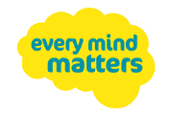
- Every Mind Matters (Part of the One You website) – Support and advice on managing and maintaining your mental health. https://www.nhs.uk/oneyou/

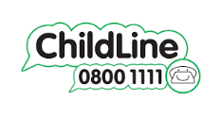
- Childline - helps anyone under the age 19 in the UK with any issue they’re going through. It is free, confidential and available any time, day or night. Phone: 0800 1111
https://www.childline.org.uk/info-advice/your-feelings/

- Bullying UK – Advice and support for dealing with
bullying. https://www.bullying.co.uk/

- Youth Beyond Blue - Information, resources and support for young people dealing with depression and/or anxiety. Aims to empower young people aged 12–25, their friends and those who care for them to respond to anxiety and depression.
www.youthbeyondblue.com

- Kooth.com - Online confidential emotional well-being platform for children and young people, aged 10-19 years old, accessible through mobile, tablet and desktop and free at the point of use.
https://www.kooth.com/

- Mood Juice - Offer information and advice. From the site you can print off different self-help guides.
www.moodjuice.scot.nhs.uk/

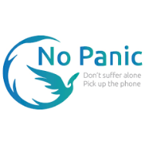
- No Panic - This site provides information for sufferers and carers of people with Panic, Anxiety, Phobias and Obsessive Compulsive Disorders (OCD).
www.nopanic.org.uk

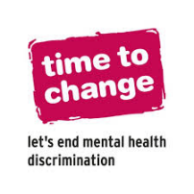
- Time to Change - Mental Health help and support services.
https://www.time-to-change.org.uk/mental-health-and-stigma/help-and-support

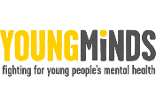
- Young Minds - Information on child and adolescent mental health.
www.youngminds.org.uk

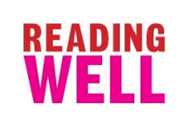
- Reading Well, Books on Prescription. Reading Well promotes the benefits of reading for health and wellbeing.
http://reading-well.org.uk/

- MoodGym - Moodgym is an interactive self-help program that provides cognitive behaviour therapy (CBT) training to help users prevent and cope with low mood and anxiety.
http://ww1.moodgym.com/

- Get Self Help – Provides lots of Cognitive Behavioural Therapy based self-help and therapy resources. https://www.getselfhelp.co.uk//

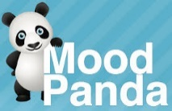
- Mood Panda - Half mood tracker, half social network. It allows children and young people to choose whether to keep their mood private or share it publicly for support from other users. https://moodpanda.com/

