Summer Term Project
Termly homework project – Due in on, to be shared week commencing 11th July.
Below is a selection of activities for you to complete independently over the next term. You can present these activities however you like: on a big sheet of paper, in a folder, as a PowerPoint, in a book – be as creative as you like. Please ask in school if you are struggling for materials. Enjoy!
Earth has had a few disasters ranging from tsunamis, floods, droughts and volcanic eruptions. Use your journalistic skills to find out some information about a disaster. Try and think of how a news reporter would tell their audience about it.  This Photo by Unknown Author is licensed under CC BY | How do animals adapt to protect themselves? Go on a quest to discover the ways in which animals adapt to their surroundings or disguise themselves away from a predator!  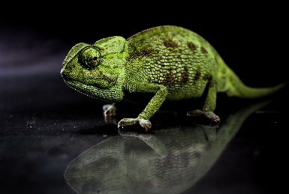 | The Commonwealth Games land in Birmingham this year. Try out one of the sports, focus on a particular athlete or team and share with us some of the interesting moments from this exciting time.  This Photo by Unknown Author is licensed under CC BY-SA
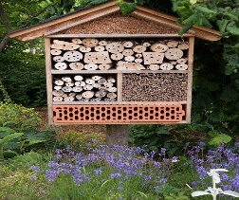  Habitats are all around us. Use your creativity to design and make your own animal hideout. You can study whether your habitat has visitors and perhaps keep a diary of your insect lodgers. | Beatlemania has arrived in Stingrays. Can you study the band, their hits and their musical history. Recreate an album cover, learn their songs and find out some facts about the Fab Four!  This Photo by Unknown Author is licensed under CC BY-NC | Create your own memories of Stingrays over the last school year. This could be a piece of writing, a memory box or something else to celebrate your year as a Stingray.  