Summer Homework projects: Minibeasts/ Heroes
Due in on Monday 11t^{h} July, to be shared throughout the week with the class.
The children are asked to complete at least one activity from the list below, if your child would like to do more they can. Your child can present their homework any way they would like, the more creative the better! Homework can be submitted either through an observation on Tapestry or by bringing their project into school. I can’t wait to see what your child comes up with.

Can you find a nice space in your garden or any outdoor space you have access to and create your own bug hotel? Think about what you will need to include in your hotel to make it nice for your minibeasts guests to come and stay.  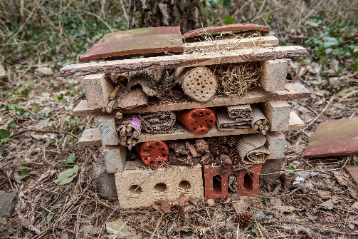 | 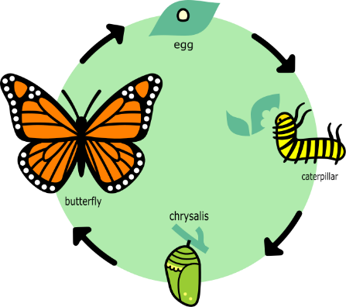  We are going to find out about the life-cycle of a butterfly during our Topic lessons. Can you find out about the life cycle of a different minibeast? Perhaps you could draw a picture of the different stages and label them.
I know that the Tiddlers and Minnows all have the abilities to be a superhero. If you were a superhero what would your costume look like? Can you design your own superhero costume? What colour will it be? Do you need a mask to hide your identity?  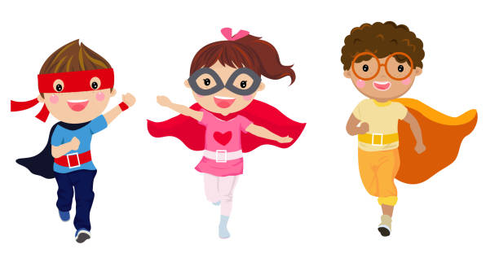 | Who is your hero? Can you tell me about them? Why are they your hero? Draw a picture of your hero and write some facts about them (Tiddlers you could get your grown-ups to help you write your facts)

